Processor Interface (PI)
10

Introduction .1
What will I learn? .2
Network Configurations .3
Processor Interface Functions .4
PI Components .4
Message Formatting .8
Data Mapping .9
Pending .11
Acquirer PI Pending .11
Financial Transaction Timing .15
Issuing PI Timeouts .16
Acquiring PI Timeouts .17
Queue Managing .18
Intercept Queue .18
Terminology .19
Processor Output Queue .20
Wait Queue .23
Queue File (QXxxxxx) .24
Stand-In/Delay Processing .27
Reasons for Activation .28
Authorization Options .30
PI Stand-In Limits .34
PI Stand-In Override Rules .36
Customer and Other Related Files .38
Transaction Flow for Delay Processing .42
Alternative Authorization Considerations .43
Exit Delay Options .44
Encrypted PIN Handling .50
Hardware Encryption Option .51
Software Encryption option .51
Status Processing .52
PI Status/Warm File (PIWARM) .53
States and Statuses .53
Command Processing .55
Common PI Commands .55
CED Relationships .58
PI Configuration Relationships .59
Processor Relationships .66
Data Mapping Relationships .72
Message Structure Relationships .81
PI Swap File (SWPPI .87
Testing and Certification .88
Simulators .89
Review .91
Appendix A .95
Intercept PI: Routines for 110x/ 120x/ 140x/ 142x/ 144x
if pending .95
Cardholder PI: Routines for 110x or 120x .96
Cardholder PI: Routines for Fin Response .97
Intercept PI to Intercept Host: Routines for Fin Response .98
Reversal With PEND to Issuer PI: Routines for Reversals .99
Reversal Without PEND to Processor PI: (Issuer Side) Routines for Reversals .100
Reversal With PEND from Acquirer PI: (Acquirer Side) Routines for Reversals .101
Appendix B .103
Session Message Options Table (CEDSOPT) Defaults .103

Processor Interface (PI)
10

Introduction
A Processor Interface (PI) is the Connex™ Advantage system module that handles the data exchange between an issuing or acquiring processor and the Advantage system. Its major functions include formatting messages and managing their timely delivery to/from a processor. There are usually several PIs in a network, and each is designed to meet specific requirements for the processor. A Processor Interface may be an Issuer only, an Acquirer only, or both. The PI and the following topics are discussed in detail:
- Processor Interface functions
Message formatting
Pending
Financial transaction timing
Queue managing
Stand-in/Delay processing
- CED relationships

What will I learn?
When you have completed this class, you will be able to:
- List the major functions of the Processor Interface
- Identify where financial transactions are timed in the Advantage system
- Explain the purpose of the Processor Output Queue, the Wait Queue, and the Queue File
- Name the options available for Delay processing
- Name the key customer files involved with a Processor Interface

Network Configurations
Each host linked to the Advantage system must have its own PI. Most networks have at least one PI, and large networks may have as many as fifty or more. The Advantage system can send administrative messages to the card issuing side of the host and to the acquiring side of the host. One Processor Interface can communicate with a host that is both an issuer and acquirer (also called an intercept processor), as long as they share the same circuit. Software changes made to the PI affect both the acquirer and issuer sides.
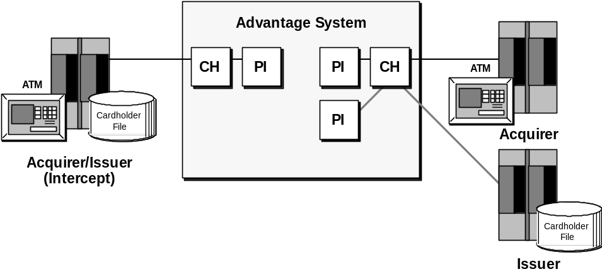
The processing environment of the host, including message format, timeout values, and more defines the PI. Therefore, specifically how transactions should be processed must be chosen. There are many options available that are implemented through user-defined parameters in the Connex™ Environmental Database (CED).

Note: | There are two options licensed into a Processor Interface at the network level single versus multiple circuits (lines) to host(s), and hardware versus software PIN encryption.

Processor Interface Functions
The primary purpose of a Processor Interface is to facilitate communications with a specific processor. There are several aspects or functions of a PI that contribute to the successful management of these data exchanges.

PI Components
The Processor Interface module consists of two primary components: Application Services (AS) and Session Services (SS). Each is defined in this section.
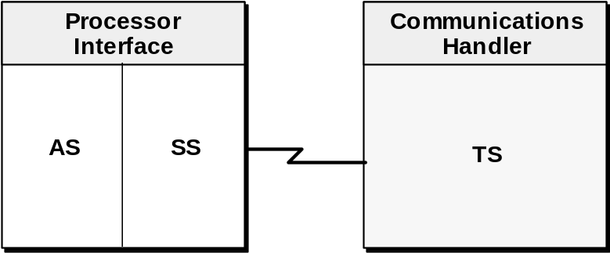

Application Services (AS)
The Application Services component of the PI is used to perform the application processing functions and performs the following standard functions:
- Message formatting
- Pending
- Financial transaction timing
- Queue managing
- Stand-In/Delay processing
- Encrypted PIN handling
- Status processing
- Command processing

Session Services (SS)
The Session Services component of the PI is used to perform the communications functions and is responsible for working with the Communications Handler (CH) process. The Session Services component of the PI works with the Transport Services component of the CH to provide the session link and the logic to execute data communication efficiently between the Advantage system and the host.
- Controls data flow.
- Controls session balancing.
- Synchronizes sessions and recovers from errors.
- Communicates with Transport Services.
Single versus multiple  session PIs | A PI may have a single or multiple sessions defined for one host. Hosts with high volumes may want to take advantage of multiple sessions. As an option, a multiple session PI may be licensed for an entire network.
Session Services controls the data flow for communication. It also controls the balancing of the multiple sessions. If an error occurs, Session Services synchronizes the sessions, analyzes the error and notifies Application Services. SS also provides AS with the action to take regarding the error, such as retransmitting a message. This information is obtained through the Session Message Options Record (CEDSOPT) in the Connex™ Environmental Database (CED). For more detailed descriptions of the Session Services component of the PI, single versus multiple sessions, and the Session Services Message Options Record (CEDSOPT), refer to Communications Handler.

Session Services Message Options Record (CEDSOPT)
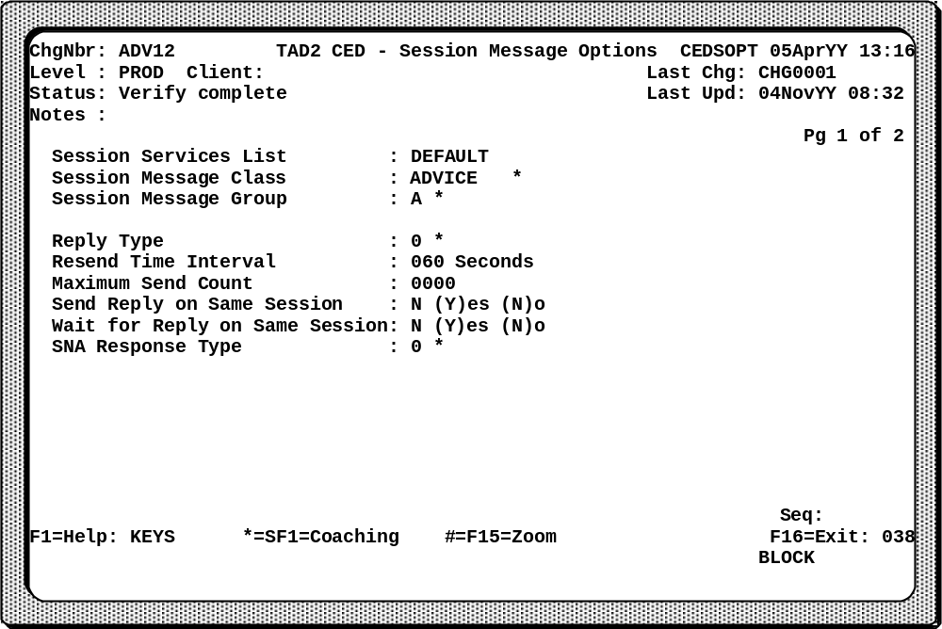
The Session Message Options Record provides a way to customize the processing of the PI session messages. The Application Services component of the PI uses the Reply Type, Resend Time Interval, and Maximum Send Count fields of the CEDSOPT Record. The SS component of the PI and the Communications Handler uses the other fields. If a PI uses the standard session messages, do not define a record in this file for that PI.
Session Services List | Contains a unique value that identifies a Session Services Message Option Table.
Session Message Class | Overrides the different types of PI application message.
Session Message Group | Indicates whether the message class is for the issuer side, acquirer side, or both.
Reply Type | Indicates the kind of application response that the Connex™ system expects from the host.

Resend Time Interval | Defines how frequently a PI resends items (e.g. advices and reversals) that the Connex™ system guarantees for delivery.
Maximum Send Count | Identifies how many times a PI resends reply required messages and must-deliver items.
The Processor Interface holds an in-memory Session Services Message Options Table. For the Session Services Message Options Table default information for each message class, refer to Appendix B.

Message Formatting
The Processor Interface is responsible for formatting the messages from the processor to the FINIPC message format used in the Advantage system, and vise versa. When the Advantage system receives the financial request message from an acquiring processor, the Communications Handler process strips the protocol envelope, adds a header to the host message in the Communications Handler InterProcess Communication format (CHIPC) and Transport Services sends it to the appropriate Session Services in the appropriate Processor Interface.
In the PI, Session Services receives the financial message and gives it to the Application Services component. Application Services formats it into the FINIPC (FINancial InterProcess Communication) adding information from the PI swap file held in its extended memory. The message is then sent on through the Advantage system.
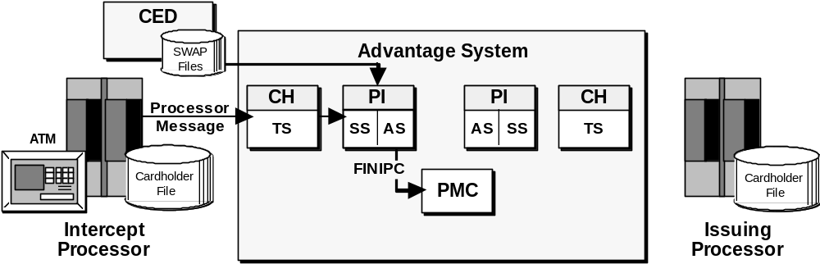

Data Mapping
There are times when business agreements require that either inbound or outbound messages are to be formatted differently. The process of replacing the data in a specific field with other data is called data mapping.
There are technically different types of data mapping as shown here. At startup time, the data maps to be used by a Processor Interface are read into its memory via the PI swap file. The data maps are taken from the Data Mapping File. Each PI has hard coded logic in it to determine which data mapping options to use when.
- Data mapping
General
Institution ID or network ID
- ISO code mapping
General data mapping can be applied to either an inbound or an outbound message. If applied to an inbound message, then data from a processor is uniquely mapped into the FINIPC. If it is done on an outbound message, then data from the FINIPC is uniquely mapped into the message format of the processor.
Some processors have agreements with each other that require that either the institution ID or the network ID be mapped differently. This happens only on outbound messages. (For the issuing PI it is on a financial request or reversal; for the acquiring PI it is on the financial reply.) In this case, Primary Message Control identifies that such an agreement exists between an acquirer and an issuer because a record exists on the Processor Options File (CEDPOPT) for these two processors. Information on how to handle the data mapping is forwarded to the outgoing PI in the FINIPC. It is also possible for two Processor Interfaces to share data mapping values and thereby create unique data maps. As it is processing, a PI is not aware that it is sharing data maps with another PI process; it is only concerned with the data map tables that it was been given at startup time.

ISO Code Mapping
The concept of ISO code mapping is similar to general data mapping. Remember that the internal FINIPC message is ISO based, so codes from incoming financial requests must be mapped to ISO codes and vice versa. Also, it is possible that the outbound mapping of an ISO code may be different than the inbound mapping. Because this code mapping is used so extensively, special records (the Transaction Field Map and the Transaction Field Code Mapping Records) have been set up in CED to facilitate it. This lessens the need for hard coding mapping values.
Examples of the categories of ISO codes that can be mapped are:
- ISO Action Codes
- ISO Message Reason Codes for advices and notifications
- ISO Message Reason Codes for reversals
- ISO Merchant Type Codes
- ISO Processing Codes for the transaction type

Note: | Other PIs may do code mapping using the Data Mapping File and the general mapping process.
Each of these data mapping concepts is discussed in more detail in the CED relationships section.

Pending
Pending is the ability to store data until it is needed at a later time. The Pend Process (PENDPROC) acts as a server process to the PI and writes data to the Pend File. This is typically done to facilitate later reversal processing. Pending is done differently by acquirer and issuer PIs.

Note: | Format 8 Processor Interfaces do not normally use the Pend Process. If an acquirer PI in the system does pend, the issuer PI does not.

Acquirer PI Pending
The acquirer PI may pend transactions in case a reversal happens and more data is required by the Advantage system. For example, a non-Format 8 acquiring PI may not hold information such as Milestone 0 (M0) in its financial message. However, if it is going to be forwarding reversal messages to a Format 8 PI, then Milestone 0 is required. To assure that Milestone 0 and other required data are available, the entire FINIPC is pended by the acquiring Format 8 PI. With the eFunds ISO PI, an option is to pend either a partial or full FINIPC.
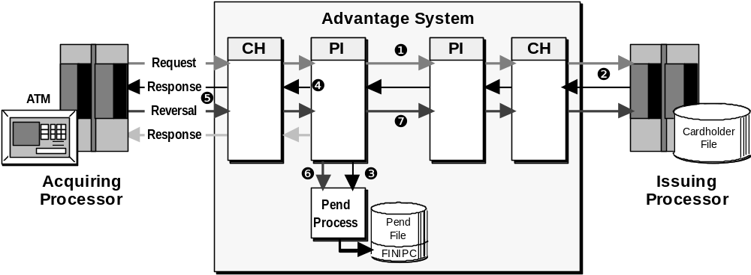
- The financial request is received, processed, and sent by the Advantage system to the issuing processor.
- The financial response is processed by the issuing processor and sent to the Advantage system.
- When the acquiring PI receives the response, it sends it to the Pend Process that writes the FINIPC to the Pend File. For Format 8 PIs, the entire FINIPC is pended; for eFunds ISO PIs, either a partial or full FINIPC is pended.
- The financial response is sent to the acquiring processor.
- The acquiring processor sends a reversal to the Advantage system for the previous transaction.
- The acquiring PI requests the Pend Process to retrieve the FINIPC for the original transaction.
- The acquiring PI sends the reversal message, updated with the financial reversal data, on to the issuing PI for sending to the issuing processor.

Note: | The number of minutes this data is pended is specified on the Processor Record (CEDPROC). If the Pend Time field contains zero (0000) minutes, then the pending default is one hour. If a reversal happens after that hour, it is generally logged as an exception.

Issuer PI Pending
The issuer PI usually pends only a selected set of fields required by the host. This may be done in case a reversal comes in from an acquiring PI that does not pend. This may also be done because of a timeout and late response from the issuing processor. By pending, the issuer PI is able to retrieve issuer-required data and supply it in its reversal to the issuing processor. Both cases are described in this section.

Acquirer PI does not Pend
If the acquiring PI does not pend, the issuing PI may pend. For example, national networks may require special information such as their trace data. Since the Advantage system does not keep this trace data, an issuer PI may use the Pend Process to store that information and supply it to the host in a reversal message.
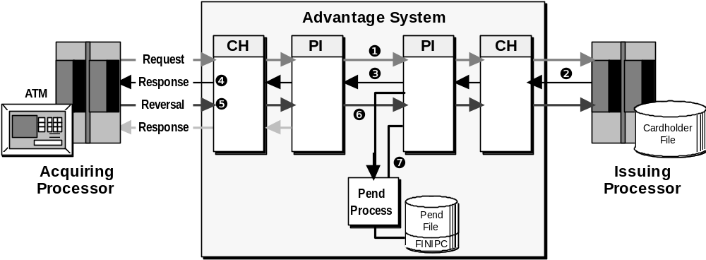
- The financial request is processed and sent to the issuing processor.
- The financial response is processed by the issuing processor and sent to the Advantage system.
- When the issuing PI receives the response, it sends it to the Pend Process that writes the information (partial or full FINIPC) to the Pend File. The issuing PI then sends the response to the acquiring PI.
- The financial response is reformatted and sent to the acquiring processor.
- The acquiring processor sends a reversal to the Advantage system for the previous transaction.
- The acquiring PI forwards the reversal to the issuing PI and returns the reversal response message to the acquiring processor.
- The issuing PI requests the Pend Process to retrieve the original information for the previous transaction, formats the reversal, and sends it on to the issuing processor.

Timeout/Late Response
In the case of an issuing processor timeout and late approved response, pending allows the Advantage system to provide data from the financial request in the reversal message to be sent, due to the late response message.
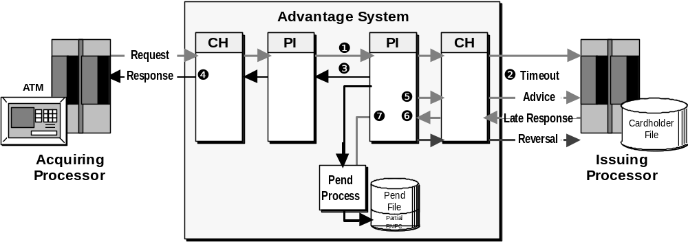
- The financial request is processed and sent to the issuing processor.
- The issuing processor does not respond in time, and a timeout occurs.
- The issuing PI sends the financial request message to the Pend Process that writes this information to the disk file. The PI also uses Delay processing, formats the appropriate financial FINIPC response, and sends it to the acquiring PI.
- The financial response is reformatted and sent to the acquiring processor.
- The issuing PI creates and sends an advice to the issuing processor for notification of the timeout if applicable.
- The Advantage system receives the late response from the issuing processor.
- The issuing PI requests the Pend Process to retrieve the pended information from the original transaction request and sends the reversal message, updated with the original financial request data, on to the issuing processor.

Financial Transaction Timing
Transactions are timed in many ways in a network. They are timed at the ATMs, and within the Advantage system. A Processor Interface times transactions for several reasons. For example, if the response to a transaction is slow, it indicates a problem in processing that needs to be addressed because cardholders need to receive a prompt answer to their financial requests.
- Why
Slow response time indicates a problem in processing.
- How
Communications Handler sets Milestone 0.
Issuing and acquiring PIs perform processor timing from Milestone 0.
- Actions
Determined by PI role and CED parameters.
There are several milestones (timestamps) set in the FINIPC that are used for timing. One key milestone is Milestone 0 which is set by the Communications Handler when a transaction first enters the Advantage system. Other key milestones include Milestone 2, which is set by the Communications Handler when a financial reply is received from a host, and Milestone 3 that is set by the acquiring PI when an ACK is received from an acquiring processor indicating it has received a financial response.
When a transaction times out, different actions may be taken by the Processor Interface based on the role it is playing in the network (acquiring PI versus issuing PI) and CED parameters. For example, a timeout may signal an issuing PI to go into Stand-In or an acquiring PI to generate a reversal.

Issuing PI Timeouts
One place where transactions are timed is between the Advantage system and the issuing processor. The issuing PI monitors a financial transaction’s time from the moment it enters the Advantage system (Milestone 0) until a reply is received from the host (Milestone 2). This is usually 20 to 30 seconds for ATM transactions, less for POS transactions.
In an intercept environment, both the acquiring PI and the issuing PI set response time values for the issuing PI to wait for a response from the host to a financial request. The lesser of the two response time values is actually used for timing by the issuing PI. The issuing PI’s value is specified in the Issuer Response Time field on page two of the Processor Configuration Record (CNFG040). The acquiring PI’s response time value for an issuing PI is specified in the Response Time field on page one of the Intercept Terminal Record (CEDINTR).
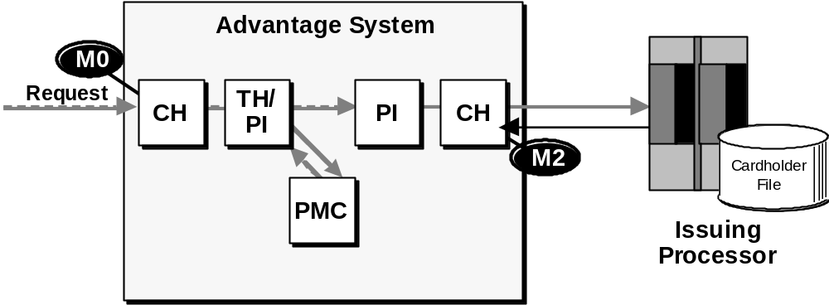
If an issuing processor’s actual response time exceeds the lesser of these two timeout values, the PI begins Stand-In processing. See the Delay processing section for more information on the possible actions that can be taken.

Acquiring PI Timeouts
In addition to stating a response time for the issuing processor to respond to a financial transaction request, an acquiring PI also states the number of seconds the acquiring processor will wait for a response before timing out a transaction. (The acquiring side was not previously timed.) This value is entered in the Response ACK Time field on page one of the Intercept Terminal Record (CEDINTR).
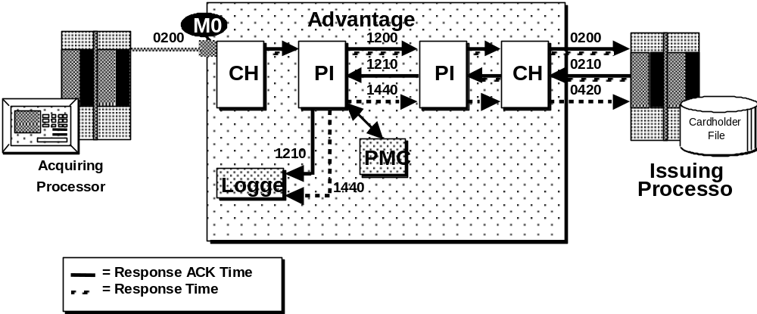
The Response ACK Time begins when the Communications Handler (CH) receives the transaction request (Milestone 0) and ends when the acquiring PI delivers the financial response to the acquiring processor. The Response ACK Time (acquiring PI’s timeout value) must be greater than the Response Time (acquiring PI’s timeout value for the issuing PI) and less than the acquiring network’s timeout value.
If the acquiring PI is unable to deliver the response within the Response ACK Time, it does not send a response back to the acquiring processor. Instead, the acquiring PI reverses the approved transaction. This reversal appears to the issuing processor like a late response; however, the acquiring PI never sent the response to the acquiring processor. Rejected transactions, under these circumstances, are just logged.

Queue Managing
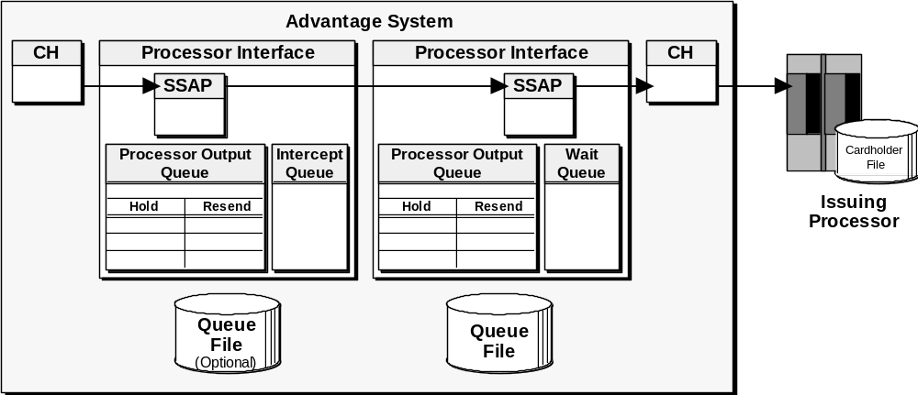
Each PI has several queues and a Queue File. Each has a specific purpose and function. The queues are used to maintain data in the PI’s memory and the Queue File is used to maintain data on disk. Each is explained in this section.

Intercept Queue
The Intercept Queue is an in-memory queue that keeps track of each transaction. It is used by some PIs for handling a reversal received from the acquiring processor during transaction processing and/or for PIs that generate reversals at the time of issuing processor timeout. Other PIs may save all or part of the financial request in order to build a financial reply.
- Some PIs use on the acquiring side.
- May be used for reversal processing.
- May be used to build a financial reply.
The Intercept Queue, unlike the other queues, is not used for Delay processing. The Processor Output Queue, Wait Queue and the Queue File are all used to perform many functions.

Terminology
There are three terms associated with Delay processing. Originally, they each described a specific function, but over the years they have come to be used interchangeably. The original definitions are provided below.
- Stand-In
- Store-and-Forward
- Delay processing
Stand-In | Perform authorizations on behalf of a host that is unavailable.
Store-and-Forward | Store copies of must deliver type messages and transmit them to the host when it is available.
Delay processing | The entire process of authorization or denial on behalf of an unavailable host, storing approved transactions, and transmitting them to the host when it is communicating again.

Processor Output Queue
The Processor Output Queue controls data transmission, ensuring that transactions are sent and received when they should be, according to the protocol being used. It is located in the PI’s memory and is shared by the issuer and acquirer sides. Messages are held in the Processor Output Queue before they are sent over the circuit if the Session Services Access Point (SSAP) is busy. This includes protocol messages as well as financial transactions. The copies are erased only when a good response (ACK) is returned from the host/processor.
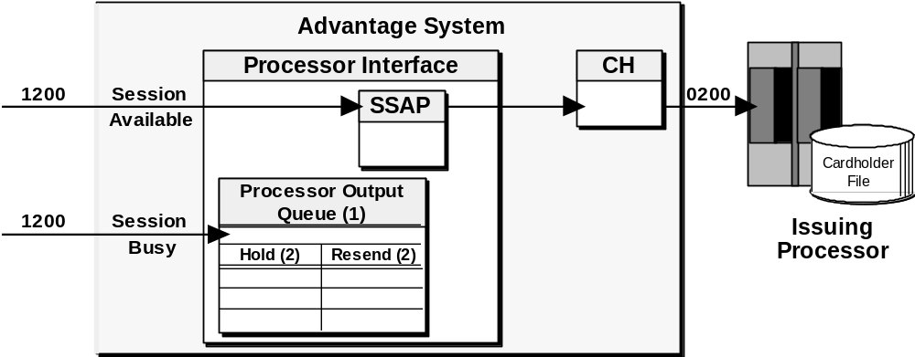
Note: | On some NAK’d items, the message is immediately re-added to the Processor Output Queue.
The Processor Output Queue is composed of the Output Queue, the Hold queues, and the Resend queues. There is one Hold and one Resend queue for each side of the PI: Issuer and Acquirer. These queues are used for holding and timing reply required messages (e.g. I44, 0420).
When a reversal message is received in the issuing PI and the session is available, the reversal is sent to the issuer. If the same PI receives another reversal message, the session is now unavailable and certain information regarding the reversal (Reply Value, Delete Flag, etc.), is placed on the Hold Queue. Refer to the diagram below.
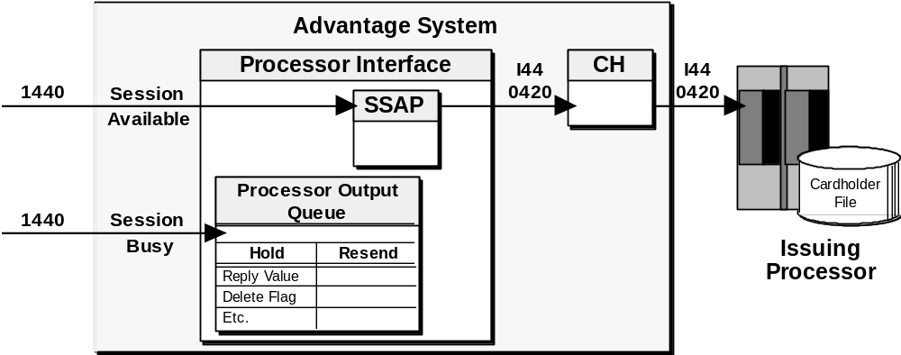
If the issuing processor responds with an ACK and not the expected reply message, the reversal is added to the Resend Queue. The message is timed for resending to the issuing processor to get the expected response message (I49/0430). This occurs until the expected reply is received from the issuing processor.
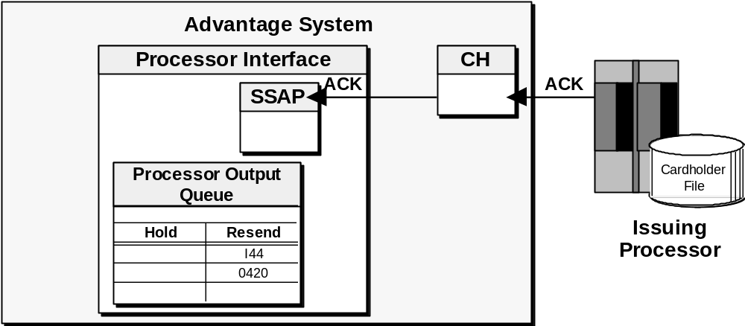

Multiple Disk Items
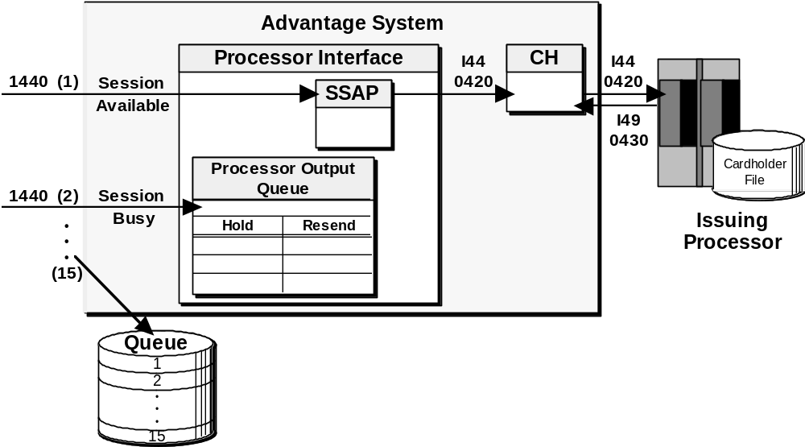
The multiple disk option enables the PI to keep up to 15 disk items in memory (Processor Output Queue). This enables the PI to use less I/O by having several items in memory and not having to go to the disk file and retrieve items singularly. However, the order of delivery is not guaranteed with the Multi Disk Items option on. This option is defined in the Multi Disk Items field on page two of the PI Configuration Record (shown later).
Also, depending on how the Session Services message options are set in the CEDSOPT record, and if the exit delay is used after first delivery (full interleaving) option (discussed later), then the multiple disk option will help getting out of delay faster. However, with the multiple disk option on, the order of item delivery is not guaranteed.

Wait Queue
The Wait Queue is critical for many of the PI’s functions. It is also located in the PI’s memory and controls the actual financial transaction timing within the Advantage system. When financial transaction requests (FINIPC) reach the PI, they are put on the Wait Queue. They are held on the Wait Queue to match the requests with the financial replies from the host. The matching fields contain unique information for each transaction and are carried in both the request and reply. (Depending on the message structure used, different fields are used for matching.)
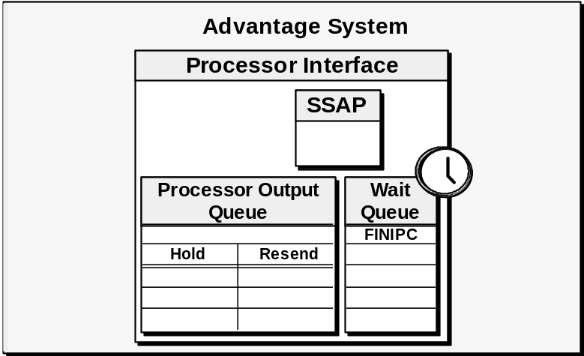
If the host does not return the financial reply in the specified amount of time (PI timed out), the Wait Queue signals the PI to begin Stand-In processing. At this time, the PI potentially produces two messages. First, a FINIPC reply is formatted and sent back to the acquirer. Second, a forced-post message (0220) is created and held, to be sent to the host when it is processing normally. The actual Stand-In and Store-and-Forward processing scenario depends upon the Connex™ Environment Database (CED) options selected.
If a transaction times out on the Wait Queue, it is assigned a Reason Code. Many possible Reason Codes exist, and are referenced in the Format 8 Interface Specifications Manual (Reason-for-Down Codes) and the eFunds ISO 8583 Specifications Manual.

Queue File (QXxxxxx)
The Queue File is a disk file that stores any must deliver messages until the processor successfully receives the message. This is indicated by an acknowledgment (for no reply required messages) or a reply message. These messages are normally transmitted in chronological order once the processor recovers, so that all activity that has been processed in its absence can be posted correctly. The first item is always retransmitted until it is accepted.

Note: | The naming convention used for the Queue File is QXxxxxx, where X is either I for intercept or P for processor, and xxxxx is the process name excluding the dollar sign. This file is sometimes referred to as the Store-and-Forward Queue.

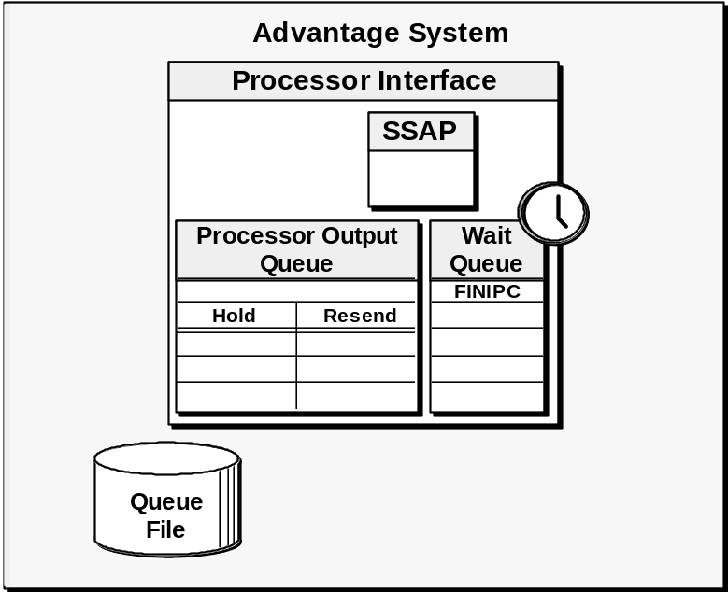
The Advantage system continues to authorize transactions in place of the processor while in Stand-In. The PI remains in Delay until the first message has successfully been delivered to the host or the Queue File is completely empty of forced-post messages. The methods used in delivering these transactions to the host are described in the Stand-In and Delay processing section.
The Queue File is located on the Customer Database. It should be kept on a mirrored disk because the records held are critical to the host. The Queue File’s physical location is specified on page two of the Processor Record (CEDPROC).
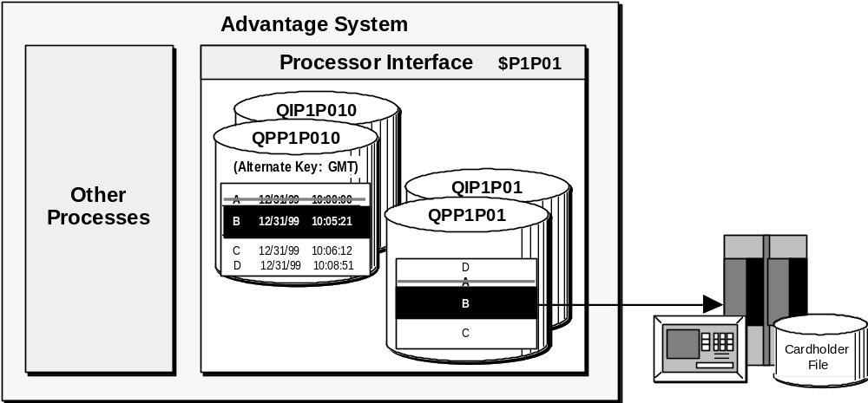
The Queue File has been established as a relative record file with an alternate key to make more efficient use of disk space. Records are written to the first available space from the beginning of the file. This means that as transactions are passed to the host, space at the beginning of the file frees up for any incoming transactions to be written to the disk file. Because of this, transactions are not in chronological order on the Queue File. Therefore, an alternate key file is used to place the Queue File records into a chronological order. The key to the alternate key file is the Greenwich Mean Timestamp (GMT) when the transaction was added to the Queue File.
There is one Queue File and one alternate key file for each side of a processor. As shown in the diagram above, the Queue File for the acquirer (intercept) side would be QIP1P01 and the alternate key file would be QIP1P010. The Queue File for the issuer side would be QPP1P01 and the alternate key file would be QPP1P010. Either of these files may be dynamically increased or decreased in size (MAXEXTENTS) as needed.

Stand-In/Delay Processing
Delay processing means the PI authorizes (approves or denies) transactions, or stands in, for the host until it is available again. The PI also stores copies of all transactions it has authorized, and transmits them to the host when communications are re-established.
There are several delay processing concepts:
- Reasons for activation
- Authorization options
- PI Stand-In limits
- PI Stand-In override rules
- Customer and other related files
- Transaction flow for Delay processing
- Alternative authorization considerations
- Exit Delay options

Reasons for Activation
There are many types of problems that can cause a Processor Interface to go into Delay, and they fall into four major categories. Each is described below.
- Host timeout
- Scheduled shutdown
- Unscheduled shutdown
- Telecommunication problems
Host timeout   | The host fails to respond to a financial transaction request within the specified time interval. This is often because of heavy volume at the host, either due to the number of online transactions processing or batch applications running on the host’s system.

Note: | The number of consecutive timeouts prior to entering delay is specified in CED.

Scheduled shutdown  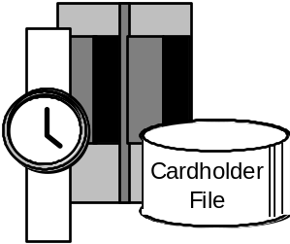 | The host’s system is normally taken down in an orderly manner and usually logs off the Advantage system. This may be done to run a batch application, roll in new software, install new hardware, or to perform maintenance.

Unscheduled shutdown  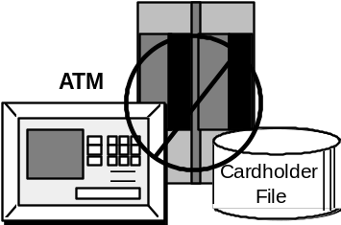 | The host’s system is not cleanly logged off. As a result, further difficulties may occur. This usually happens when the host’s system fails due to a malfunction, disk crash, loss of power, or a CPU failure. Power outages frequently cause lengthy system problems at the host. Many types of software problems at the host location can also cause unscheduled outages. This actually results in a host timeout.
Telecommunication problems   | Inconsistencies or lack of communication through telephone lines are the most common source of communication problems. Noise or static on circuits can cause intermittent problems. A line that is cut can cause a long outage until it is repaired! Hardware, like muxes and modems, can also malfunction causing communication failures. Improper timing between modems causes synchronization problems.  If the circuit is completely down, no communication takes place at all. A good safeguard for this problem is to establish a backup circuit that may be implemented if the primary circuit fails for any reason.

Authorization Options
The Advantage system must have a set of procedures to follow if the host is not communicating or processing transactions. When a processor is down, the Advantage system always performs Stand-In processing. The processor must decide whether to permit the Advantage system to authorize transactions or to deny all transactions in their absence.
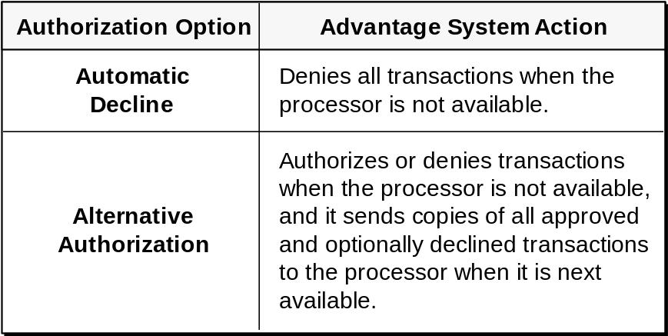

Automatic Decline
The host can decide to have all their transactions denied when they are unavailable; this is called automatic decline. All transactions normally routed to the affected host are rejected using one of the following Action Codes: 911 for timeout, 910 for logged off, 912 for delay, or the Action Code set up with Primary Message Control. The host decides whether or not to receive an advice message about these transactions. If they do not want advice messages, no advice transactions are stored in the Queue File.
A host must consider many factors before they decide to use automatic decline.
- No overdrawn accounts
- No money issued to lost or stolen cards
- No manual settlement report changes
- Cardholders inconvenienced
- Host may lose credibility among cardholders

Alternative Authorizations
The other choice for a host is to allow the PI to perform alternative authorizations. In this case, the PI authorizes (approves or denies) the host’s transactions, while the host is down, using predefined rules. Copies of these accepted transactions are created and stored on the Queue File. The host receives these transactions when it is processing again.
- PIN verified (PMC)
- Usage limits checked
- Dollar limits checked
- Customer files accessed
Negative File
Usage File
Queue File
Most processors elect to use the alternative authorization option. This means that the PI authorizes transactions on behalf of the host based on a certain set of rules to follow. All transactions authorized by the Advantage system must meet these requirements.
Primary Message Control plays an important role in Delay processing. It passes the Stand-In limits, which limits to check and update, and Stand-In override rules to the Processor Interface through the FINIPC.

Routing Information Record (CEDROUT) Relationships
The required links to the Stand-In processing limits and override rules are provided by PMC through the Routing Information Record. There are four key fields on the Routing Information Record that affect PI Stand-In processing.
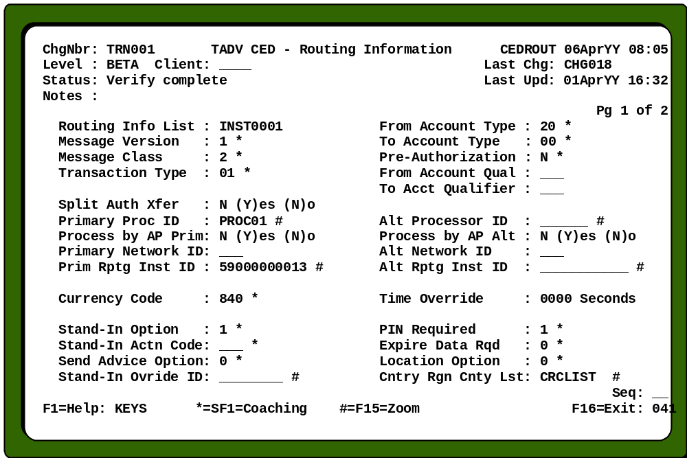
Stand-In Option | Specifies which set of rules a PI uses during Stand-In processing.
Stand-In Actn Code | Identifies the ISO Message Action Code that goes into an approved financial request during Stand-In processing.
Stand-In Override ID | Identifies information that overrides the Stand-In rule for a transaction. The Stand-In Ovride ID field on the Stand-In Overrides Record links to this field.
Send Advice Option | Specifies when the Connex™ system sends advices and/or notifications to the host.

PI Stand-In Limits
Usage and dollar limits are pre-established for the number of times during the day that a cardholder may use a card during Delay processing. These limits are defined by card base on the PI Stand-In Limits Record. Because Stand-In processing limits are set at the card base level, they are passed to the Processor Interface from Primary Message Control (PMC) in the FINIPC.
The PI ONLY checks the Usage File during Stand-In processing. Limits are NOT tracked while the host is processing normally. Therefore, the PI is unaware of activity conducted by a cardholder who performed transactions while the host was communicating.
- Defined at the card base level.
- Passed to the PI from PMC in the FINIPC.
- Maintained on the Usage File during Stand-In processing only.

Note: | If using the Authorization Processor for stand in, PI Stand-In limits is not needed.

PI Stand-In Limits Record (CEDSTDL)
The PI Stand-In Limits Record identifies the Stand-In limits. This information is passed from PMC to the PI with each transaction. It is the PI that actually uses this information during Stand-In processing.
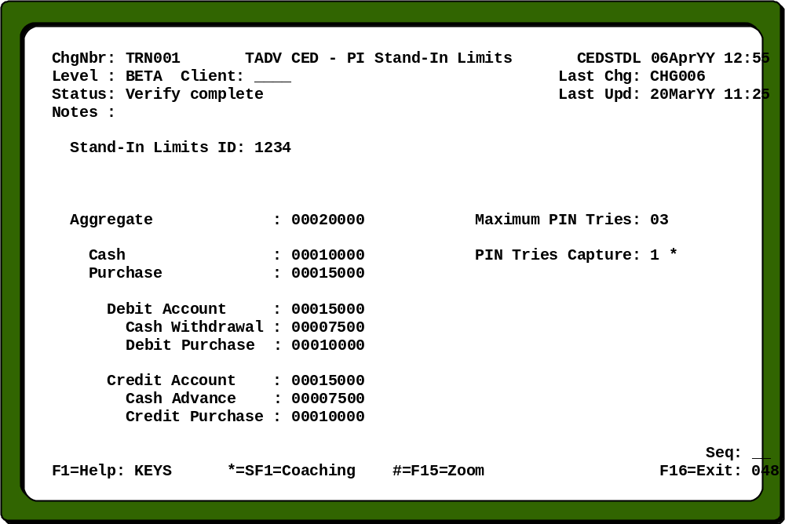
Stand-In Limits ID | Identifies the Stand-In limits for a group of cards. The PI Stand-In Lmt ID field on either the Card Base, Destination Routing, Direct Routing, or Default Routing Record links to this field.

PI Stand-In Override Rules
- Stand-In rules may be overridden at the transaction level.
- Stand-In override rules are passed to the PI from PMC in the FINIPC.
The standard processing rules for a Processor Interface in Delay can be overridden for specific transactions. This is done through the PI Stand-In Override Record (CEDSTDO). Primary Message Control passes values in the PI Stand-In Override Record to the PI through the FINIPC.
For more information on the role of PMC in Stand-In processing, refer to the Primary Message Control section.

PI Stand-In Override Record (CEDSTDO)
The PI Stand-In Override Record identifies information that overrides the default Stand-In processing options for a transaction. The record includes information on how the PI is to accumulate limits for debit accounts, credit accounts, cash, purchases, and an aggregate total. This information is passed to the PI in the FINIPC.
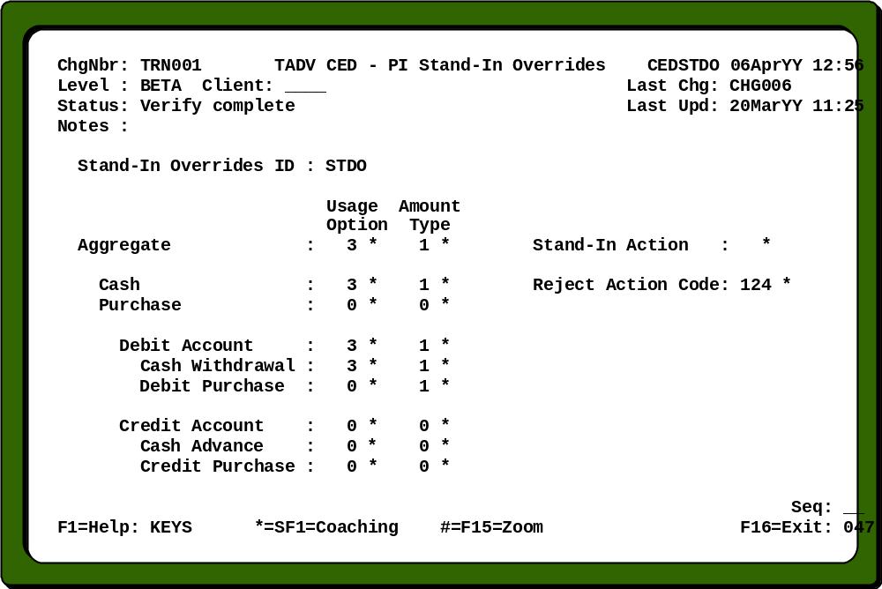
Stand-In Override ID | Identifies information that overrides the Stand-In rule for a transaction. The Stand-In Ovride ID field on the Routing Information Record links to this field.
Stand-In Action | Provides the action to be taken in Stand-In; whether to update the limits for a default, force approval, force denial, or force a referral.
For complete descriptions and valid field values, see the Connex™ Environmental Database Reference Manual and the Primary Message Control (PMC) section.

Customer and Other Related Files
The PI must have access to three customer files for alternative authorization to take place: the host Negative File, the Stand-In Usage File, and the Store-and-Forward Queue File. These customer files reside on the Customer Database.
- Resides on the Customer Database
Negative File
Usage File
- Event Record signals daily reset of Usage File.
The Queue File has already been discussed in detail in the Queue Managing section. The Negative File, Usage File, and Event Record are explained next.

Negative File (NEGxxxxx)
The Negative File contains a list of the current bad risk cardholder. Transactions for cards listed in the Negative File are denied with a Reason Code supplied by the host. Cardholders are added to the Negative File if their card was reported as lost or stolen, they have overdrawn their accounts, or they are a bad risk for another reason.
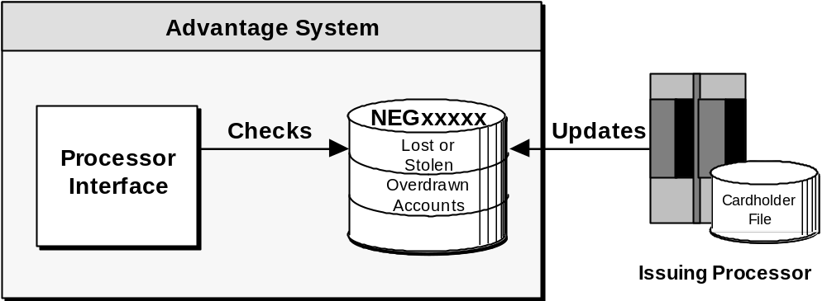
It is critical that the Negative Files are kept current. The host on a daily basis, using one or more of the methods below, does this maintenance:
- Batch processing
- Online maintenance through the Processor Interface
- Online maintenance through an administrative terminal using Negative Status Maintenance (NSM)

Note: | The Negative File’s physical volume.subvolume location is specified on page three of the PI Configuration Record (CNFG040). A Negative File is required for each processor.  It is suggested that one Negative and one Usage File be established on the Customer Database for each processor. It is possible to have one Negative or Usage File that is accessed by all the PIs, but this is not recommended since it is more difficult to replace one file than separate files. If processors wish to share a Negative or Usage File, the Share Stand-In field (volume.subvolume) must be completed on page three of the PI Configuration Records (CNFG040). The naming convention used is NEGxxxxx or USGxxxxx, where xxxxx represents the processor name.

Usage File (USGxxxxx)
The Usage File tracks the number of bad PIN tries and the daily dollar limits for the issuer’s cardholders during Stand-In processing. These limits are added to the FINIPC by the PMC process after routing has been determined. The limits are established on the PI Stand-In Limits Record and are cleared once every 24 hours by the PI through the Event Manager.
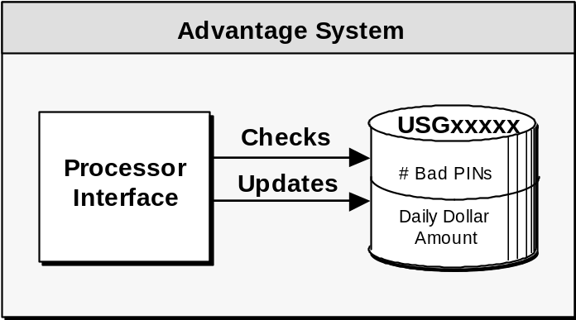
This file is used ONLY during Delay processing. The Usage File is NOT accessed when the host is processing normally. This means that the PI has no information regarding daily usage during any time other than in Stand-In processing.

Note: | The Usage File’s physical volume and subvolume location is specified on page three of the PI Configuration Record (CNFG040).

Event Record (CEDEVNT)
A record must be entered in the Event File to signal the Event Manager to reset the Usage File (USGxxxxx) once every 24 hours. For complete descriptions and valid field values, see the Connex™ Environmental Database User’s Manual.
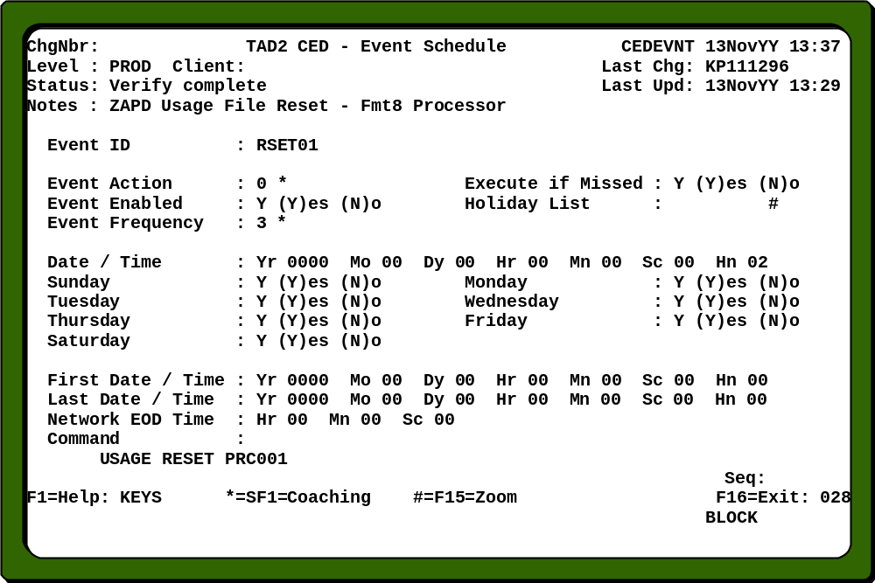

Transaction Flow for Delay Processing
The financial transaction flow changes when a request reaches a PI that is in Delay. Remember, by this time PMC usually has performed PIN validation. If the PIN is good, and the Quick Kill option is not being used by PMC, the transaction goes to the PI. The diagram below shows the transaction flow within the issuer PI.
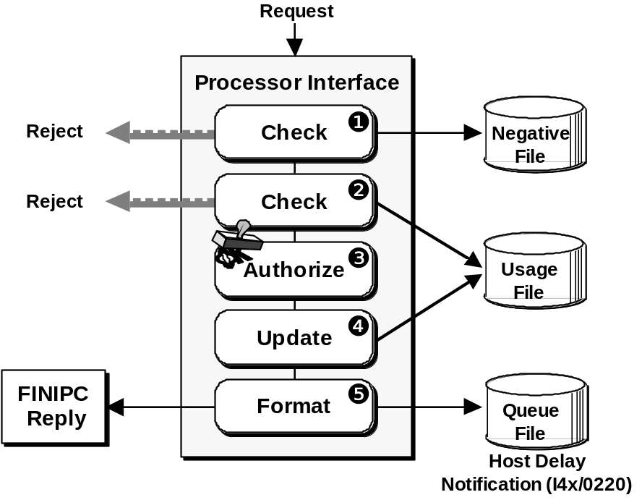

- Check the Negative File. If the cardholder is found, reject the transaction with the Reason Code supplied by the host.
- Check the Usage File. Has this card exceeded its number of bad PIN tries since the last time the file was reset? Is the request within the pre-established limits?
- Authorize the transaction if it is within the limits; reject it if it is over the limits.
- Update the Usage File with this transaction’s information if the transaction is authorized.
- Format a forced-post message, and the FINIPC transaction reply message to return to the terminal. The forced-post message is held on the Queue File.

Note: | If a transaction is reversed at the ATM, the Usage File is not updated

Alternative Authorization Considerations
When a processor chooses to have the Advantage system perform alternative authorization, they must take several things into consideration. First, by choosing this option, the loss of their host is transparent to most cardholders, and they are likely to be more satisfied. There is less risk of lost business from unhappy cardholders.
On the other hand, it is possible to approve transactions that overdraw an account since the PI does not have access to balances. Each host’s financial risk is equal to the limit amounts established for each card base, and the overdrawn situation is reflected in the daily settlement reports.
- Continuous system availability
- Customer satisfaction
- Reduced risk of lost business
- Risk equals daily limits for card base
- Requests approved may overdraw an account

Exit Delay Options
If a host elects to use Stand-In processing, there are two options for PIs to use in clearing the Queue File. These options are defined in the Exit Delay field on page three of the PI Configuration Record (shown later). Valid entries are 0, exit Delay after first delivery (full interleaving) or 1, exit Delay after all delivered.
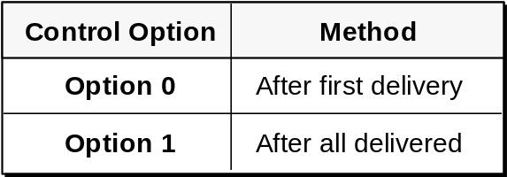

Note: | The following examples for each method are shown using Format 8 and ISO messages; however, the same concepts that are being illustrated apply to most format interfaces.

After First Delivery (Full Interleaving)
This method specifies that the PI exits Delay processing after the first message has successfully been delivered to the host. This exit Delay option is sometimes referred to as full interleaving.
Hosts that are concerned with availability commonly use this method. In this method, all forced-post transactions are sent to the host as the lowest priority message. New transactions that arrive for the host can be processed immediately, reducing the risks involved in transactions authorized by the PI.
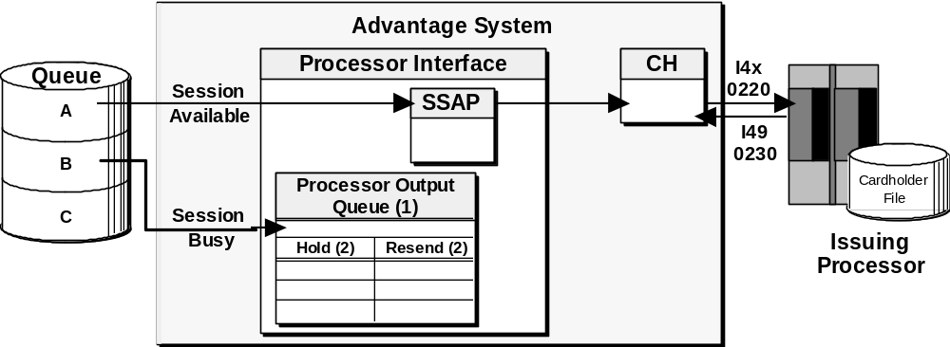

Note: | The example above illustrates the PI with the multi-disk option off.
Before full interleaving begins, the host must receive the first item and return an ACK or a response message.
Each remaining queued transaction (item B) is sent on a priority basis. New transactions are sent as they occur. They are still sent on a priority basis, but the queued transactions are all considered the lowest priority; all new transactions have a higher priority.
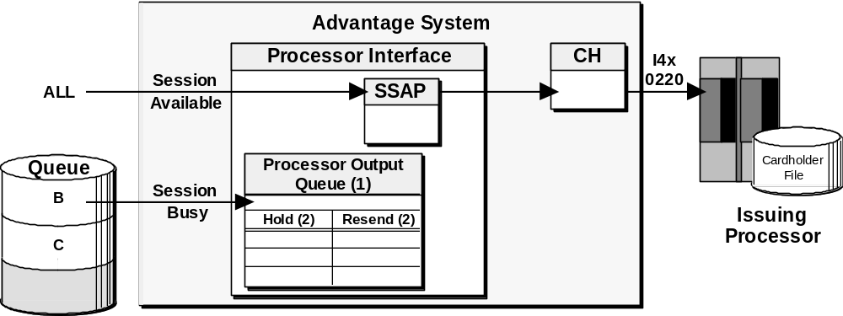
Priority for transactions is:
1. Network messages
a. Handshakes (I00 or I01/0800 or 0820)
b. Start and Stop (I02/0800)
c. Logon (I11 or I12/0800)
2. Forced-Post Completion Message (I49/0430)
3. New Financial Transaction Request (I31/0200)
4. Remaining Forced-Post Messages (any I4x type/0220)
5. Other non-financial transactions

After all Delivered
This method specifies that the PI exits Delay processing after all of the queued messages have been delivered in chronological order to the host. New transactions that arrive for the host are processed by the PI using the Stand-In rules until the Queue File is completely empty. This method is used if the host needs authorized transactions prior to new requests.
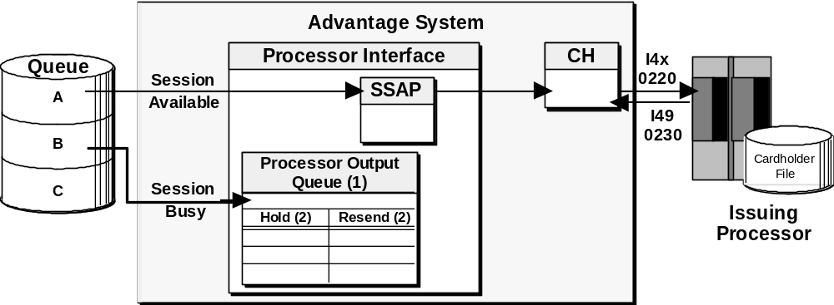
The host receives the first message (item A in the queue) and replies with either an ACK or a response message.
Note: | The example above illustrates the PI with the multi-disk option off.
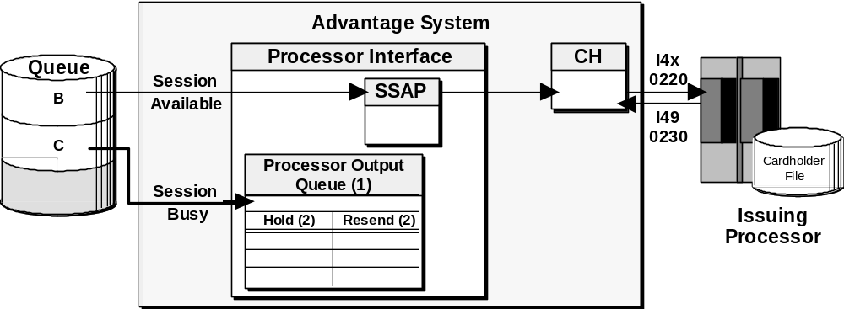

Each remaining queued transaction (item B in the queue) requires the same expected reply from the host.
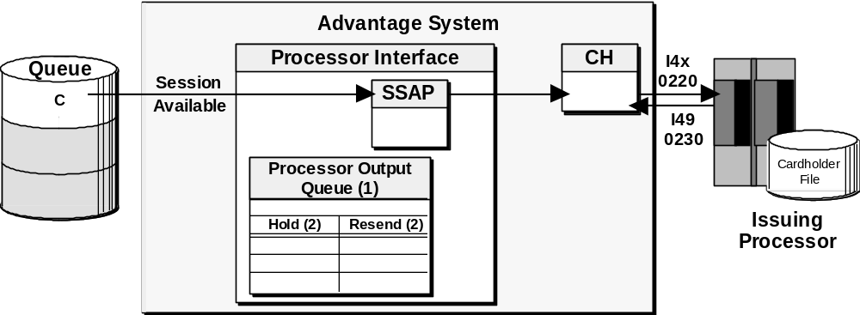
The system will NOT send new request transactions to the host until it receives the reply to the last queued message (item C in the queue). Any new transactions for the host are processed in Store-and-Forward until the queue is empty of all transactions.

Factors in Exiting Delay
One major factor that helps to determine when a Processor Interface exits Delay is whether full interleaving is being used. Other factors include:
- Whether or not full interleaving is being used
The Queue File is empty
- An Exit Delay message is ACKed or replied to
- Issuer sessions are re-established
- The Delay time has been reached
A PI that is not using full interleaving cannot exit Delay until the entire Queue File is empty; so no matter what else might trigger a PI to exit Delay this condition must be satisfied. Another condition that can trigger a PI to exit Delay is an Exit Delay message that has been either acknowledged or replied to. Also a PI can be signaled to exit Delay when an issuer session is re-established. There is also a Delay Timer (screen 6 of CNFG040) that can signal a PI to exit Delay when no other way exists to exit Delay.

Encrypted PIN Handling
There are three types of processes associated with PIN security: PIN validation, PIN encryption, and PIN translation. The process of assuring that the cardholder has entered the PIN correctly is called PIN validation. The process of scrambling the PIN during a financial transaction request to keep it secure from others is called PIN encryption. The process of changing a PIN from one encrypted form to another is called PIN translation.
The Processor Interface is responsible for handling encrypted PINs for financial, and network management requests. Within the Advantage system, there are two types of encryption (or translation) methods available: hardware and software.
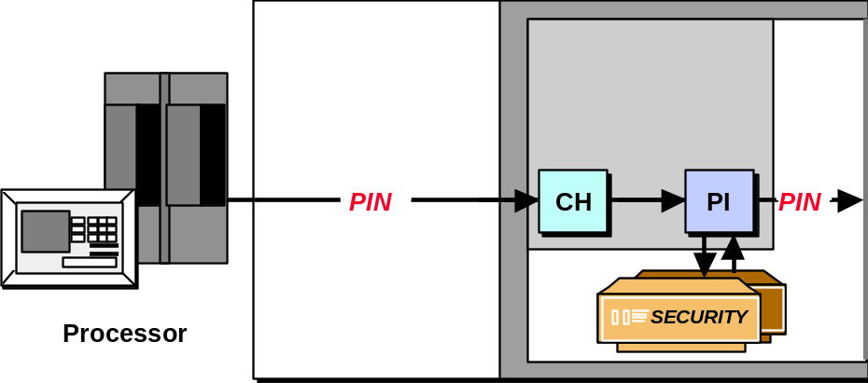

Hardware Encryption Option
When hardware encryption is used, the acquiring Processor Interface directs the message for PIN translation to a security device attached to the Advantage system. After translation, the security device sends the translated PIN block back to the Processor Interface, which forwards it to Primary Message Control.
Primary Message Control may or may not validate the PIN. If the encrypted PIN block is being forwarded to the host for validation, then the issuing Processor Interface uses a similar technique to translate the PIN block again before it is sent to the host.

Software Encryption option
When software encryption is used, the Processor Interface decrypts the PIN block and may transform it and send it to Primary Message Control for PIN validation. This is the less secure of the two methods.

Status Processing
Status information is used at startup time for processor recovery purposes, and throughout the day to report state and status information for Network Monitoring. It is kept in the Processor Interface’s memory and contains data about the processor and its status.
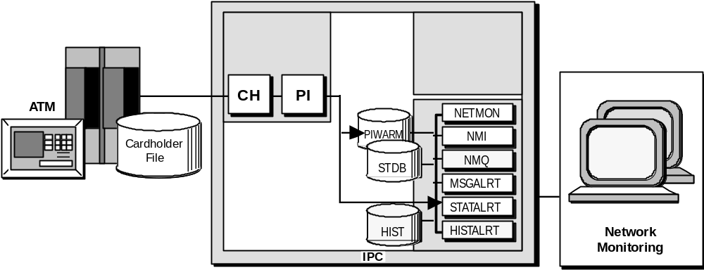
The PI is responsible for maintaining this status information and sending it to the Status Alert (StatAlrt) process when appropriate. StatAlrt logs the statuses and routes them to the Message Alert (MsgAlrt) process. MsgAlrt builds the text for display and sends it to the appropriate Network Monitor Interface (NMI), which displays the information to the operator. For example, if a processor logs on, the PI processes the information and sends a message to the Network Monitor processes, which displays a message on the network console. Network operators must take appropriate action in responding to changes to processor status information.

PI Status/Warm File (PIWARM)
- Holds state and status information.
- Contains one record per processor.
- Resides on the Status Database.
The PI Status/Warm File (PIWARM) stores status and business date information about processors that is used at startup time, for recovery purposes, and throughout the day to report state and status information for Network Monitoring. It resides on the Status Database and contains one record for each processor: acquirer and/or issuer. The PI updates the PIWARM File at startup time and upon state and status changes. As part of the status information, the Store-and-Forward (SNF) count is held in the PIWARM File. This contains the number of queued items in the Queue File.

States and Statuses
- States
Logged on
In Delay
Logged off
- Statuses
Auto reject
Missed 10 handshakes
Key exchange errors
Queue item stuck
There are only three states a processor may be in. If a processor is logged off and Delay processing is being used, the NMI screen only shows the state Logged Off on the NMI screen. This is because a process may only be in one state at a time. The status information indicates if there is a fault with the processor.

Both states and statuses appear in the A window of the Network Monitoring Interface (NMI) screen; and both states and statuses cause network monitoring messages to be displayed in the B window of the NMI screen. The NMI displays the last state of the processor. Refer to the sample Network Monitoring Interface screen illustrated below.
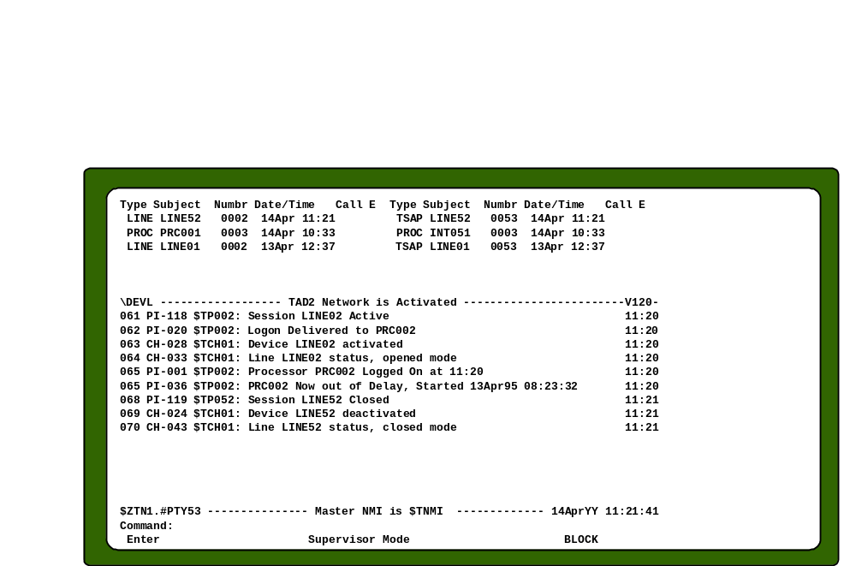
Each state and status has its own message associated to it (also set in the database). In addition, there are many other messages that may be displayed by the PI. These network message may be highlighted, non-deletable, logged only, or various other types. The messages are explained in the Network Monitoring Messages Manual.

Command Processing
The PI is also responsible for processing requested information regarding hosts. Current status information for Processor Interfaces is held in the PI Warm File. Using the data from this file, many network monitoring commands display different types of processor status information on the NMI screen.

Common PI Commands
There are several commands that are commonly used by network operators as they monitor processors. Some of these commands and their functions are:
- POp QUEue <processor ID> (<reply number>)
- REFresh SWap <process name>
- SWap NEG NEW <PI process>
- SWap NEG OLd <PI process>
- SWap NSF NEW <PI process>
- SWap NSF OLd <PI process>
POp QUEue <processor id>  (<reply number>) | Discards an item in the specified processor’s queue. Should be used when an item is either experiencing repeated failures when transmitted, or is not being answered by the host.
REFresh SWap <process name> | Instructs the PI to de-allocate its proprietary swap file and look in the Swap File Locator Extract File for the current productive swap file.
SWap NEG NEW <PI process> | Instructs the PI to swap to new negative files.
SWap NEG OLd <PI process> | Instructs the PI to swap to old negative files.
SWap NSF NEW <PI process> | Instructs the PI to swap to new not sufficient funds (NSF) files.
SWap NSF OLd <PI process> | Instructs the PI to swap to old not sufficient funds (NSF) files.

PRCS versus PROC
Depending which option is chosen at the time of purchase, different PI commands are used at the Network Monitor Interface to send messages to either one or both sides of the PI. If the acquirer or the issuer side is to receive or send a message, the PROC command is used. If both the acquirer and the issuer sides are to receive or send a message, then the PRCS command is used. The Network Management Option is specified on page two of the PI Configuration Record (CNFG040). Command examples include:
- INITIATe LOGON/LOGOFf PRCS $xxxxx both sides
- INITIATe LOGON/LOGOFf PROC prc001 one side
- INITIATe HANdshake PRCS $xxxxx <ssap and/or tsap>
- INITIATe HANdshake PROC prc001 <ssap and/or tsap>
- KEY CHANge PRCS $xxxxx
- KEY CHANge PROC $xxxxx
INITIATe LOGON PRCS  <process name>  INITIATe LOGON PROC  <processor id> | Notifies the specified processor that the network is ready to accept transactions.
INITIATe LOGOFf PRCS  <process name>  INITIATe LOGOFf PROC  <processor id> | Notifies the specified processor that the network is no longer accepting transactions.
INITIATe HANdshake PRCS  <process name> (<tsap id>)  INITIATe HANdshake PROC  <processor id>(<tsap id>) | Issues a single handshake message. Optionally, which session (tsap) to use to send the handshake can be specified.
KEY CHANge PRCS  <pi process>  KEY CHANge PROC  <processor id> | Initiates a Key Change (if master for keys) or a key change request (if slave for keys) if dynamic key PIN encryption is being utilized.
One of the more commonly used processor commands and it’s display screens are illustrated next. For more information, refer to the Network Monitoring Messages Manual.

SHOw PROC <processor id>
The SHOw PROC command displays the processor in detail, giving the operator the current status and configuration information about the processor. Refer to the screen below.
1. Key SHOw PROC PRC001 on the Command line.
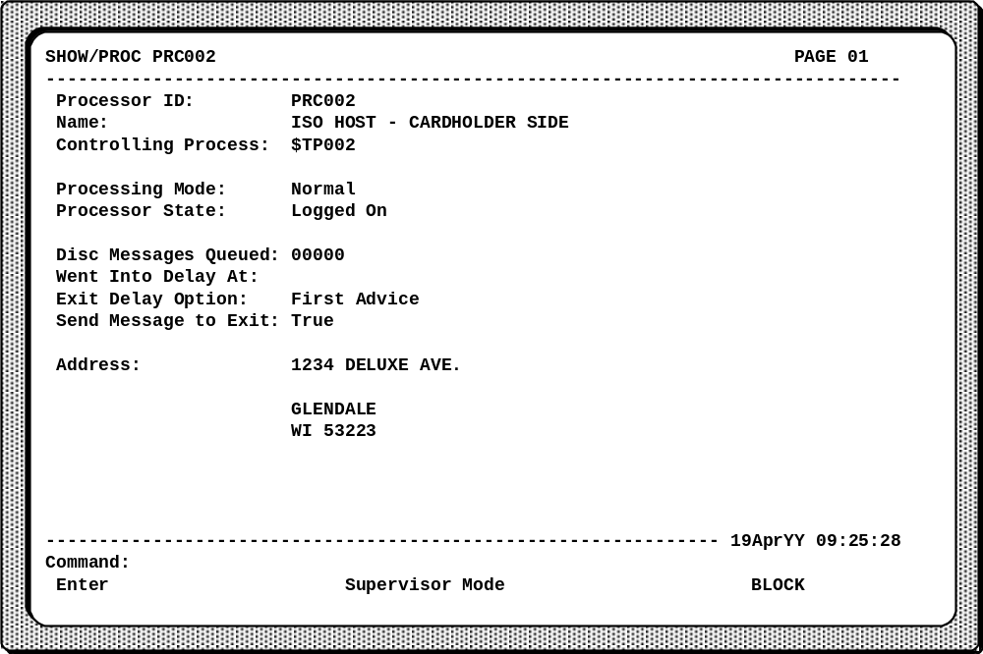
2. Press the Return key.
3. Press the Prev Page key to view the display.

CED Relationships
Processor Interfaces use several files in the Connex™ Environmental Database (CED). These files are explained in four sets. The first set (PI configuration) describes the configuration of the physical environment of the host and how the PI links to other processes within the Advantage system. The second set (processor) describes the processing environments for a host that handles both acquiring and issuing traffic. The third set (data mapping) describes transaction field and data maps. The fourth set (message structure) describes the Format 8, ISO 8583, and other message structures that the processor uses to communicate.
Each of the records shown here is explained in more detail in this section. For more information, refer to the Connex™ Environmental Database User’s Manual.
- PI Configuration relationships
PI Configuration Record (CNFG040)
- Processor relationships
Intercept Terminal Record (CEDINTR)
Processor Record (CEDPROC)
Acquirer/Issuer Processor Options Record (CEDPOPT)
- Data mapping relationships
Transaction Field Map Table Record (CEDMTBL)
Transaction File Code Mapping Record (CEDCMAP)
Data Mapping Record (CEDDMAP)
- Message structure relationships
Format 8 Processor Operations Record (CED8OPT)
ISO 8583 PI Options Record (CEDIOPT)
ISO Definition Record (CEDIMSG)
ISO Bit Map Record (CEDIBIT)

PI Configuration Relationships
The Processor Interface Configuration Record provides links to each of the other sets of relationships. The PI Configuration Record also provides a link to the Session Services Message Options Record.
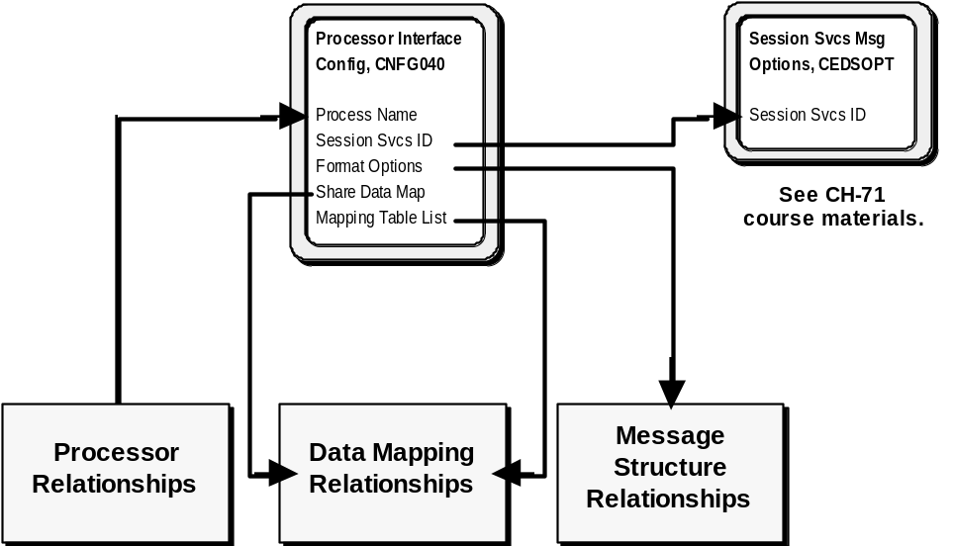

Processor Interface Configuration Record (CNFG040)
The Processor Interface Configuration File is used to define the PI process. It includes parameters for CPU priority utilization and identifies other Advantage system processes for communication with the PI.
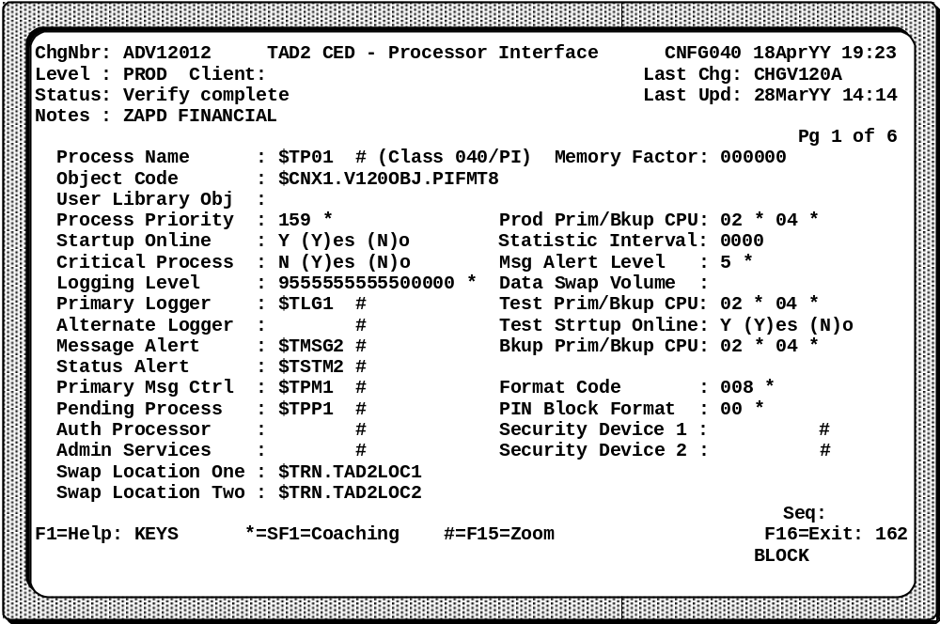
Process Name | Identifies the unique name assigned by the technical staff for this process.
Process Priority | Assigns the execution priority of this specific process.
Critical Process | Specifies whether this process must always be operating in an Advantage system.
Logging Level | Controls what segments of the internal financial message a Logger stores in an activity log file.
Swap Location One and Two | Identifies the volume.subvolume for the PI swap file.

Screen 2 of 6
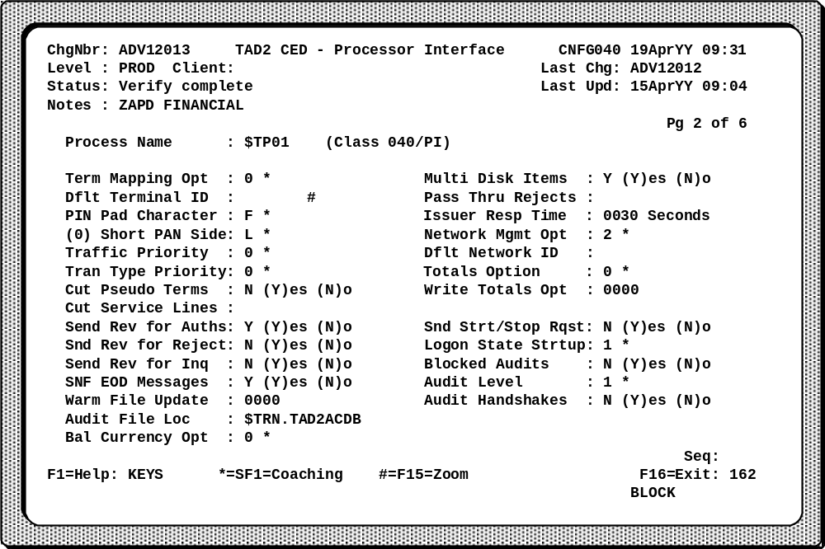
Term Mapping Opt | Enables a PI to map either terminal types or a combination of terminal type and acquiring institution ID into a pseudo terminal.
Multi Disk Items | Determines whether the PI keeps up to 15 disk items in memory. The use of this option allows for the bursting of disk items. (Order of delivery is NOT guaranteed with this method.)
Dflt Terminal ID | Identifies an intercept terminal. If the Term Mapping Opt field indicates mapping, leave this field blank; if no mapping is indicated, this field may be used to identify an intercept terminal.
Issuer Resp Time | Indicates how long an issuing PI waits for a response from the issuing processor to a financial transaction request.
Network Mgmt Opt | Controls if the host uses network management messages, and whether the same or separate messages are used for both sides of a processor (provided a processor is both an issuer and an acquirer).

Screen 3 of 6
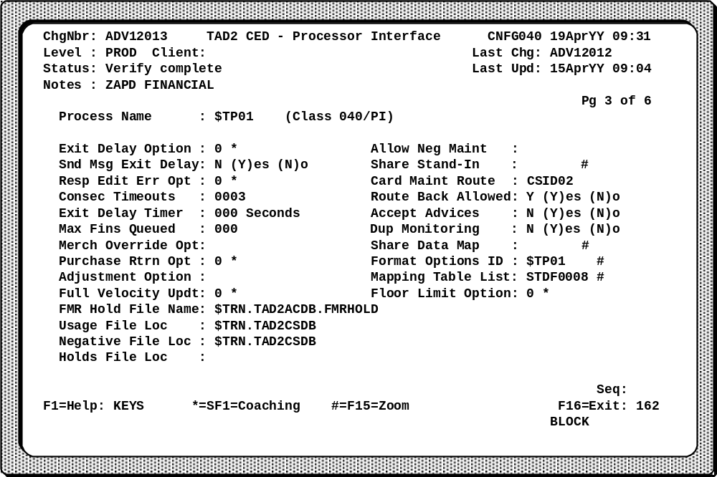
Exit Delay Option | Determines when a PI that is in Delay comes out of Delay.
Snd Msg Exit Delay | Identifies if the issuing side of a PI should send a message to the processor to force the PI to get out of Delay processing.
Share Stand-In | Identifies a PI that shares files with this PI during Stand-In processing.
Consec Timeouts | Defines when a processor goes into Delay processing. Delay processing occurs after the specified number has been reached. If this number is 0, the PI will never go into Delay.
Accept Advices | Identifies whether the PI accepts advices from the host.
Share Data Map | Identifies a shared list of data mapping values.
Format Options ID | Contains the linking identifier of the record that specifies the message structure options for a particular PI (e.g. CED8OPT, CEDIOPT).

Mapping Table List | Contains a linking value which identifies one or more records in the Transaction Field Map Table File (CEDMTBL) that define special mapping for specific ISO codes (e.g. ISO Action Codes, ISO Reason Codes).
Usage File Loc | Identifies the volume and subvolume location of the Usage File used by this PI.
Negative File Loc | Identifies the volume and subvolume location of the Negative File used by this PI.

Screen 4 of 6
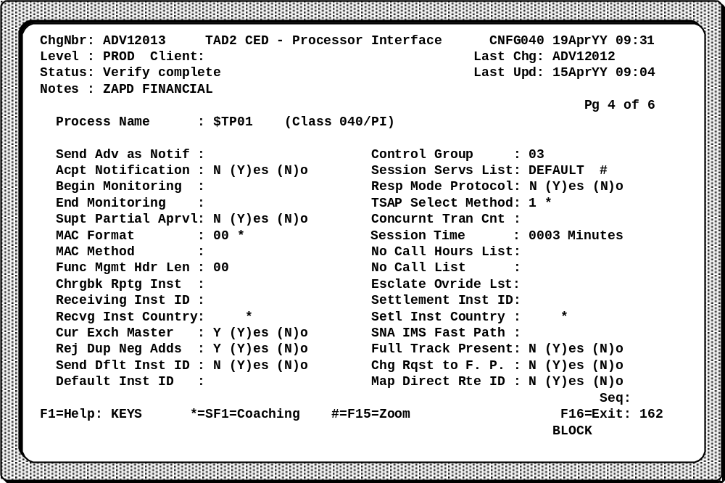
Send Adv as Notif | Identifies whether the PI sends advices as notifications. (Future)
Acpt Notification | Identifies whether the PI accepts notifications from the host.
Supt Partial Aprvl | Determines whether the PI supports transactions that the issuer partially approves. (Future)

Screen 5 of 6
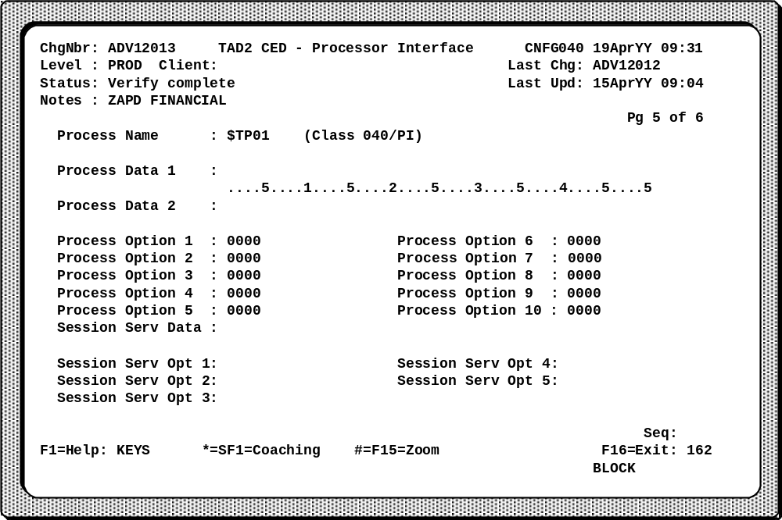
Process Data 1 | Contains unique character information for this PI. Refer to the PI documentation for more details.
Process Option 1 | Contains unique numeric information for this PI. Refer to the PI documentation for more details.

Screen 6 of 6
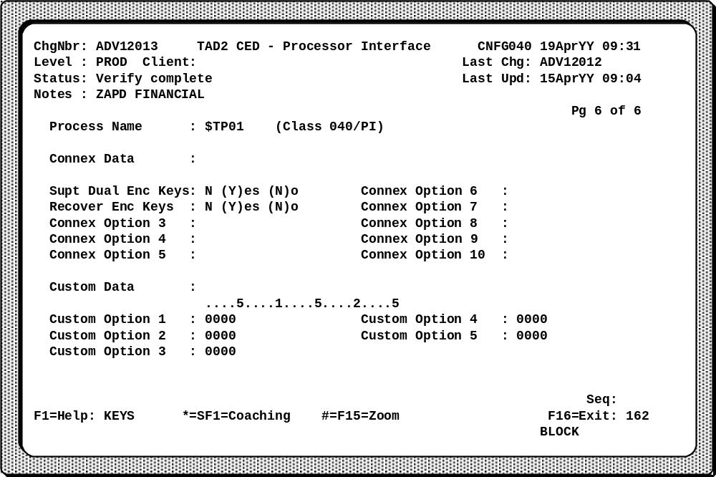
Delay Time | Contains the number of seconds a processor is in Delay if no other way exists to exit Delay for this processor. Other ways to exit Delay include delivery of notifications, advices, or in certain PIs, some other message such as a handshake.

Processor Relationships
The following diagram illustrates CED relationships between processors with specific field names relevant to the processors. Notice that the diagram is shown in three distinct sections: those relationships used by the acquiring processor, those used by Primary Message Control and passed in the FINIPC to the issuing processor, and those used by the issuing processor.

Note: | For details on the CED relationships used in PMC to determine the authorizer (or Primary Processor ID), refer to the Primary Message Control (PMC) section.

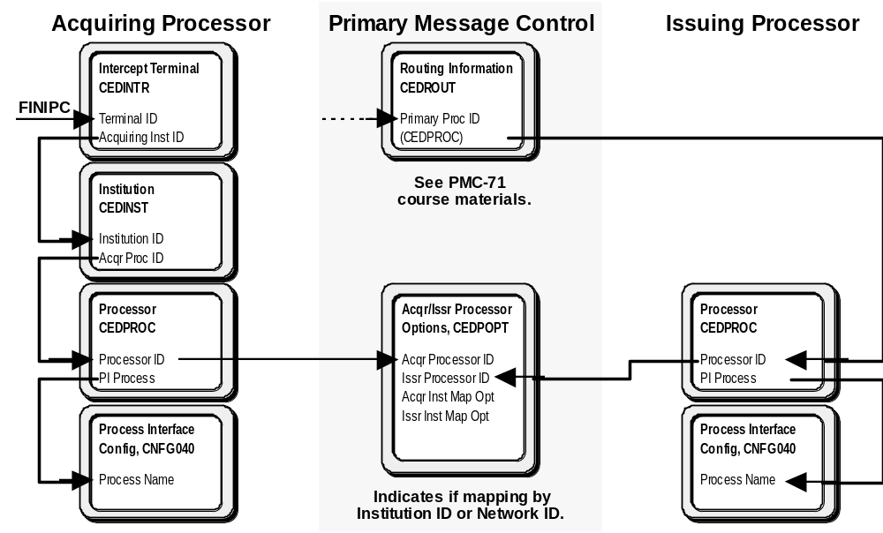

Intercept Terminal Record (CEDINTR)
The Intercept Terminal Record identifies a group of terminals defined by an acquirer. Each record defines values used to process transactions for the group of terminals. The intercept terminal is separate from the real terminals.
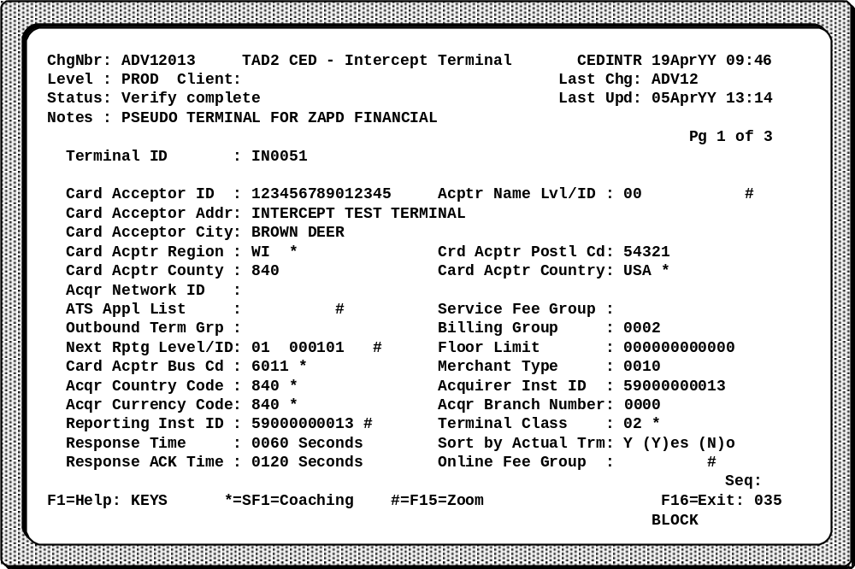
Terminal ID | Identifies an intercept terminal that receives transactions from an acquiring processor.
Response Time | Specifies the number of seconds a financial request message has to be replied to by the issuing processor.
Response Ack Time | Specifies the time interval the acquiring PI will return the response to the acquirer. If this time expires, the reply is treated as a negative acknowledgment (NAK) by the Advantage system to the acquiring processor.
Reporting Inst ID | Identifies the institution related to this intercept terminal. May be used to link the institution to the intercept processor.
Acquiring Inst ID | Identifies the acquiring institution or is blank. If this field is blank, the Reporting Inst ID field is used.

Screen 2 of 3
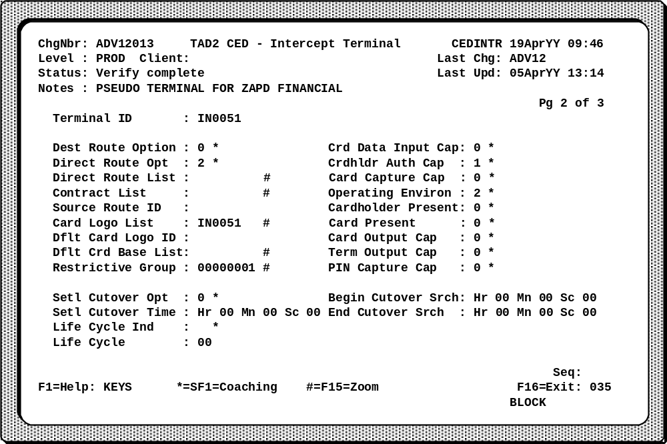
Crd Data Input Cap | Indicates the primary means of getting the information on the card into the actual terminal.
Crdhldr Auth Cap | Indicates how to check that the cardholder has authorization to use the card.
Card Capture Cap | Indicates whether the actual terminal has the ability to capture a card.
These and the rest of the POS data fields in the right column of this record define the capabilities of the terminal behind the pseudo terminal for the processor, not what actually occurred.

Institution Record (CEDINST)
The Institution Record identifies institutions for the purposes of settlement reporting, online transaction processing, and security. One record is required for each institution.
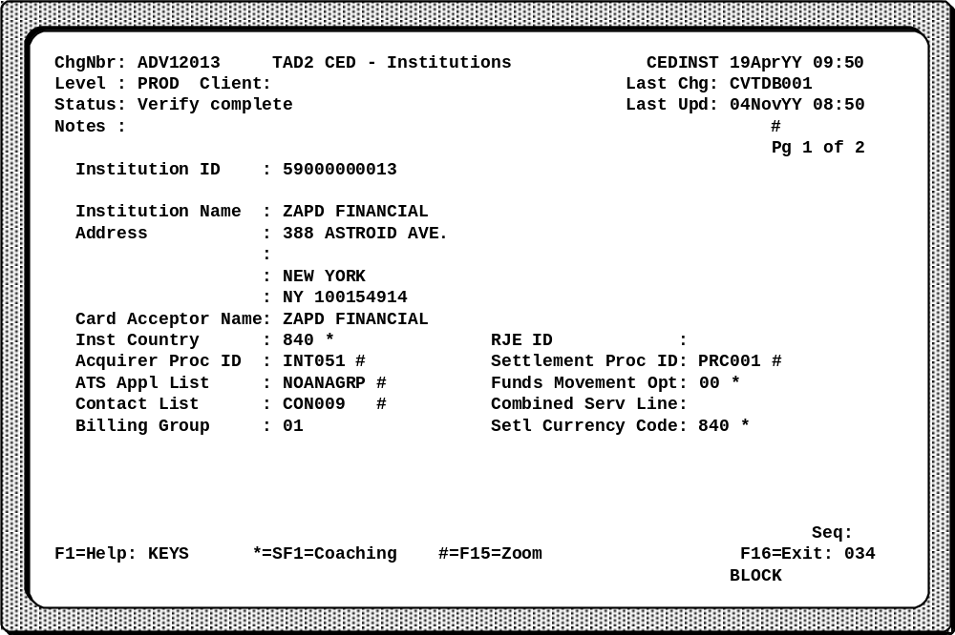
Institution ID | Identifies an institution.
Acquirer Proc ID | Identifies the processor for an acquiring institution.

Processor Record (CEDPROC)
The Processor Record contains unique information about the host’s business environment. One record is required for each issuer and each acquirer even if they share the same line and PI.
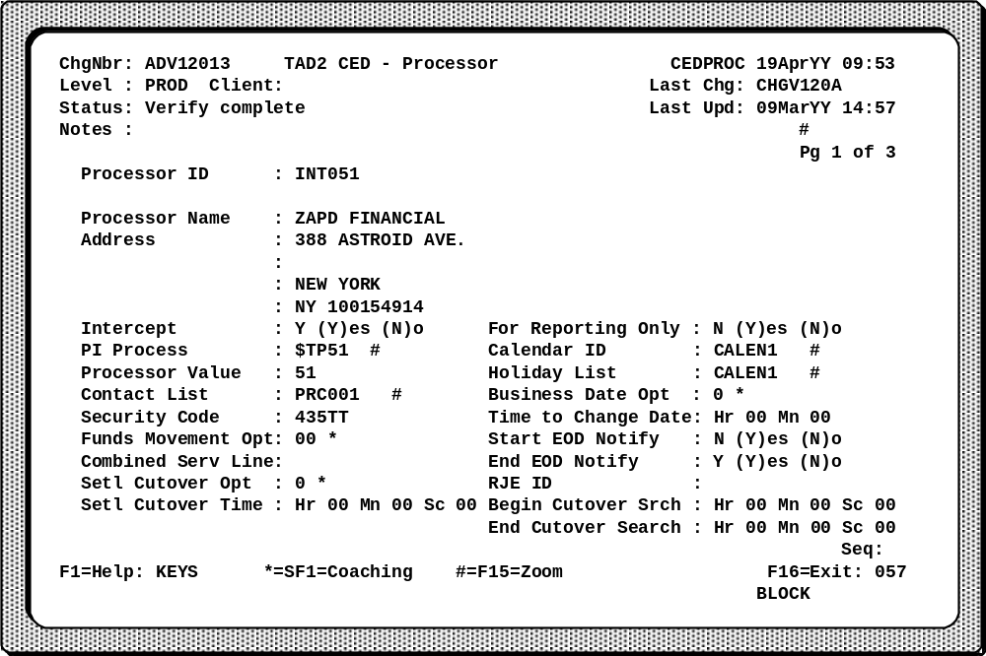
Processor ID | Contains the unique identifier assigned to an acquiring (intercept) PI or an issuing PI.
Intercept | Indicates if this record identifies an acquirer.
PI Process | Identifies the processor configuration information.
Calendar ID | Identifies a record in the Calendar File (CEDCALR) that lists the business days for the Advantage system.
Holiday List | Identifies the records in the Holiday List File (CEDHDAY) that define the non-business dates.

Screen 2 of 3
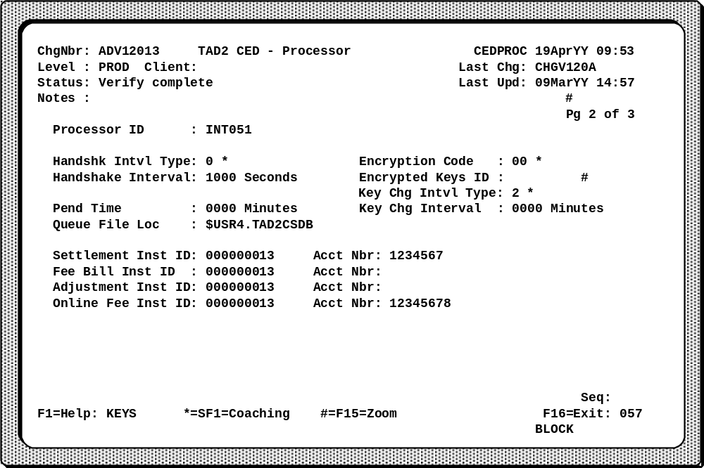
Handshk Intvl Type | Determines if the PI sends a handshake after every handshake interval expiration or only if there is no line activity.
Handshake Interval | Sets the interval in minutes between automatic handshake messages. If this is 0, the Advantage system does not send automatic handshake messages.
Pend Time | Indicates the number of minutes the PI should pend for reversal processing.

Note: | If Pending is turned on but no (0) minutes for Pending Time, pend defaults to 60 minutes. If Pending is not wanted, pending must be turned off on the Format 8 Processor Options Record (CED8OPT) or the ISO 8583 PI Options Record (CEDIOPT).

Data Mapping Relationships
An important function of the Processor Interface is to format messages from an external to an internal format, or vice versa. To do this correctly, some data mapping may be required. There are three different data mapping concepts.
- General data mapping relationships
- Institution ID or network ID data mapping relation ships
- ISO code mapping relationships
The first two concepts require the Data Mapping File. The Data Mapping File (CEDDMAP) is the key to the general data mapping, and institution ID or network ID data mapping relationships.

Data Mapping Record (CEDDMAP)
The Data Mapping Record allows a PI to map information based on a field’s value and type. If the PI matches the mapping information (input data type, input value, and output data type), it maps the output data into a message, either internal or external.
The sample screen shown below shows a scenario where an issuing processor requires that a zip code (Output Data Type ZP) be passed in its unique message structure to a host. Because the acquiring (or intercept) PI does not have a zip code in the message that it receives, it simply passes the state code in the FINIPC. When the issuing PI formats the request for the host, it maps the state code (Input Data Type ST, Input Data WI) in the FINIPC to the specific zip code (Output Data 53223) from the Data Mapping Table.
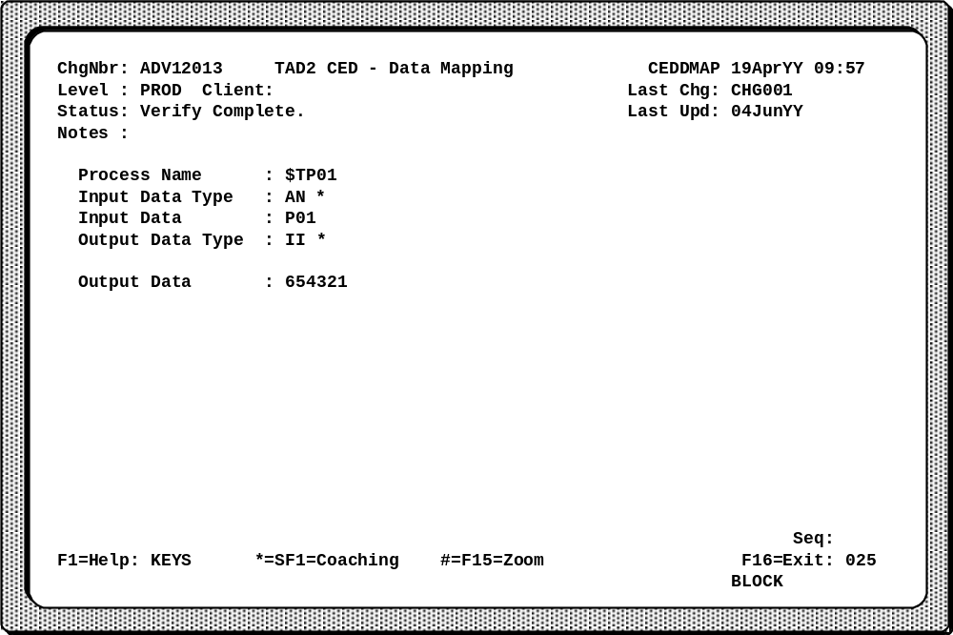
Process Name | Identifies a unique value for a specific processor.
Input Data Type | Identifies the kind of information in the Input Data field.
Input Data | Contains a value that the PI matches. After finding a match, the PI stores the Output Data field in another field. The fields that the PI uses vary.
Output Data Type | Identifies the kind of information in the Output Data field.
Output Data | Contains a value that the PI uses after finding a match on the following fields. The PI stores the data in a message destined for the host or stores the information within an internal message.

CED Relationships for General Data Mapping
As mentioned in the Message Formatting section, general data mapping can be done for either inbound or outbound messages. Data mapping is hard coded into the Processor Interface. The fields that are to be data mapped from either an inbound message to the FINIPC or from the FINIPC to an outbound message are identified for the PI in the Data Mapping File.
The diagram shown below indicates on the left how a given standard PI process is linked to a standard set of Data Mapping Records. It is possible to customize the data mapping options for a similar PI (shown on the right) by using the Share Data Map field on the PI Configuration Record. Pointing to the standard PI process in the Share Data Map field provides the standard data map set. The unique data mapping options are provided by completing unique records on the Data Mapping File for the customized PI.
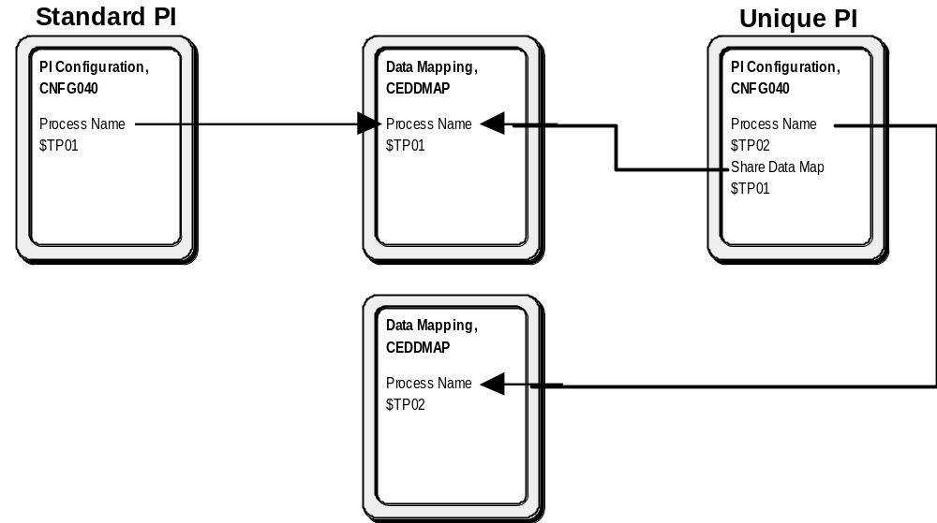

CED Relationships for Institution ID or Network ID Data Mapping
Data mapping of the institution ID or the network ID forms a subset of the general data mapping requirements for outbound messages only. The mapping of institution IDs can provide useful information for handling transaction adjustments. In order for this type of data mapping to happen, a unique business agreement must be established between the acquiring processor and the issuing processor.
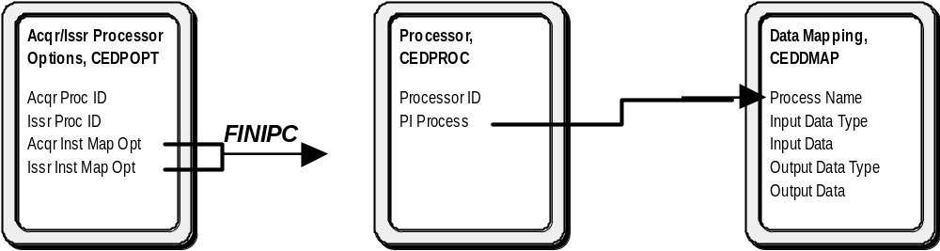
Primary Message Controls identifies the link between an acquirer and an issuer through its routing procedures. As part of its standard processing, PMC searches for a common Processor Options Record (CEDPOPT). If a record is found, then data from the record is passed in the FINIPC.

Acquirer/Issuer Processor Options Record (CEDPOPT)
The Acquirer/Issuer Processor Options Record identifies how a PI provides a recognizable institution ID in outbound messages. The information on this record identifies the acquiring processor, the issuing processor, and the method for mapping the institution ID. If a mapping option is to be used, PMC and the issuing PI use this file to map the original institution ID to an outbound institution ID (values held in CEDDMAP) and vice versa. If mapping options are not used (such as in an all Format 8 switch), this record is not needed.
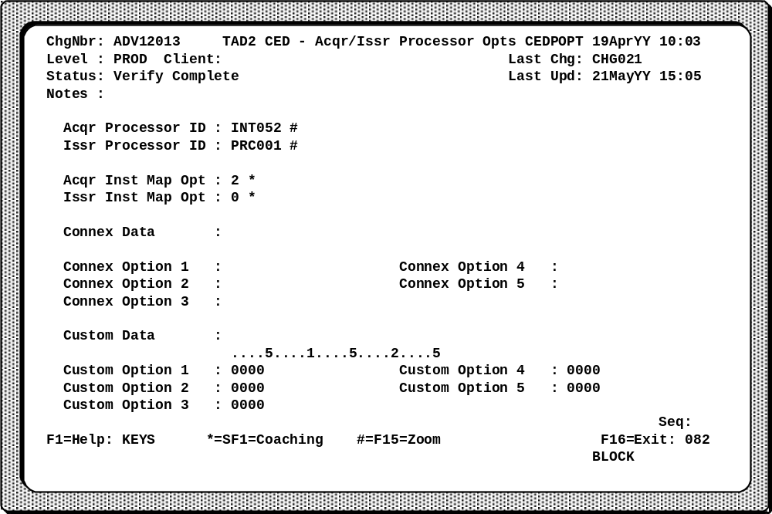
Acqr Processor ID | Identifies the processor for the acquiring side of a PI.
Issr Processor ID | Identifies the processor for the issuing side of a PI.
Acqr Inst Map Opt | Defines how to provide an acquirer institution ID in an outbound request for transactions between these two processors. An issuing PI uses this field.
Issr Inst Map Opt | Defines how to provide an issuing institution ID in an outbound response for transaction between these two processors. An acquiring PI uses this field.

CED Relationships for Action Code Mapping
ISO code mapping is used to map codes from an external message format into the internal ISO-based FINIPC (and vice versa). Like general code mapping, ISO code mapping is based on the PI process. The PI Configuration Record links a PI process to a specific table of Action code maps through the Transaction Field Mapping Table Record and the Transaction Field Code Mapping Record. The following diagram shows the CED relationships for Action Code mapping.
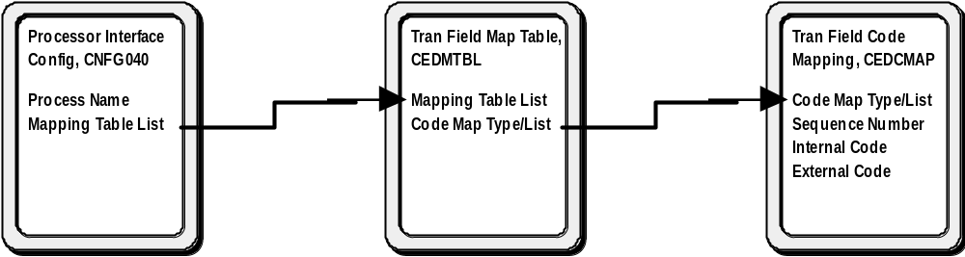

Transaction Field Mapping Table Record (CEDMTBL)
The Transaction Field Mapping Table Record identifies lists of mapping options for several categories of ISO codes. This record is referenced by PIs that map between the internal financial message (FINIPC) and a different external message structure. The values identify the mapping options, a list of codes, and the mapping direction. The Transaction Field Code Mapping Record (CEDCMAP) identifies the ISO codes within each list specified on this file.
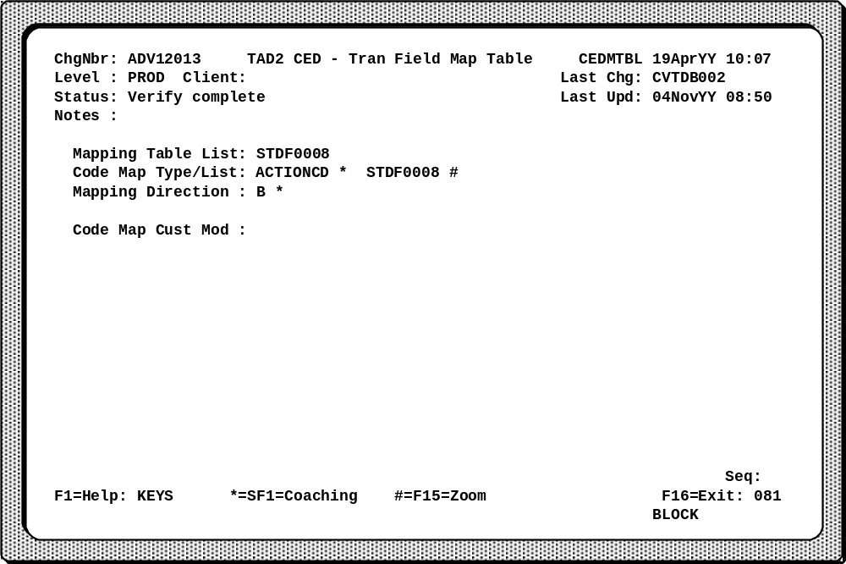
Mapping Table List | Contains a value that identifies one or more records that define special mapping for these ISO codes.
- ISO Action Codes
- ISO Message Reason Codes for advices and notifications
- ISO Message Reason Codes for reversals
- ISO Merchant Type Codes
- ISO Processing Codes for the transaction type
Code Map Type/List | The Code Map Type field identifies a category of ISO codes. The Code Map List field identifies a code list. These fields have a key relationship to the Code Map Type/List fields in the Transaction Field Code Record.
Mapping Direction | Identifies when a PI uses the Code Map List in this record for mapping. This field allows a PI to map inbound and outbound message differently if necessary.

Transaction Field Code Mapping Record (CEDCMAP)
The Transaction Field Code Mapping Record provides lists of ISO codes. A PI uses these lists for mapping codes between the internal financial message (FINIPC) and an external message structure. This file initially contains the standard default codes for each PI. Examples include the Format 8 PI (STDF0008) and the eFunds ISO 8583 PI (STDF040). The Transaction Field Mapping Table Record (CEDMTBL) identifies each list of mapping options. The ISO codes within each list are in the CEDCMAP File.
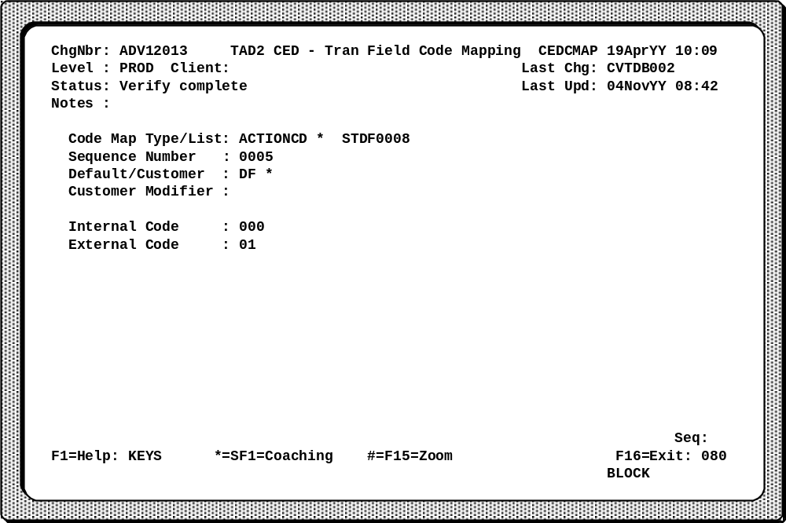
Code Map Type/List | The Code Map Type field identifies a category of ISO codes. The Code Map List field identifies a code list. These fields have a key relationship to the Code Map Type/List fields in the Transaction Field Map Table Record.
Sequence Number | Identifies the order of the records for the code list defined in this record. A PI maps the codes in the order defined in this field. For all codes, the last record in a code list identifies the default mapping values.

Internal Code | Identifies the value of the code in the internal financial message (FINIPC) within the Advantage system. This code must correspond to the code map type in the Code Map Type/List field. These are the possible categories of ISO codes.
- ISO Action Codes
- ISO Message Reason Codes for advices and notifications
- ISO Message Reason Codes for reversals
- ISO Merchant Type Codes
- ISO Processing Codes for the transaction type
External Code | Contains the code that corresponds to the code in the Internal Code field.
The relationship between the PI Configuration Record, Transaction Field Map Table Record, and the Transaction Field Code Mapping Record is illustrated below. The graphic also depicts the keys to each of the respective files.
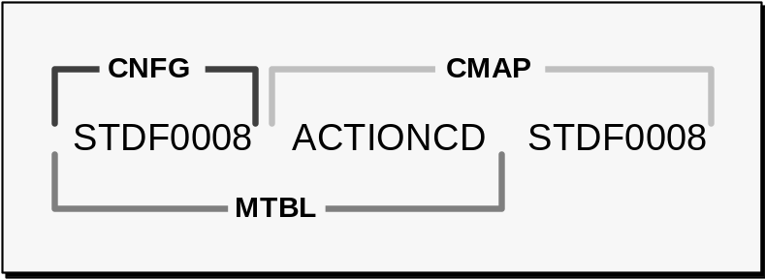

Message Structure Relationships
The following diagram illustrates the records and specific field names relevant to the message structure that a processor uses to communicate with the Advantage system. Each record is explained in this section. For complete descriptions and valid field values, refer to the Connex™ Environmental Database Reference Manual.
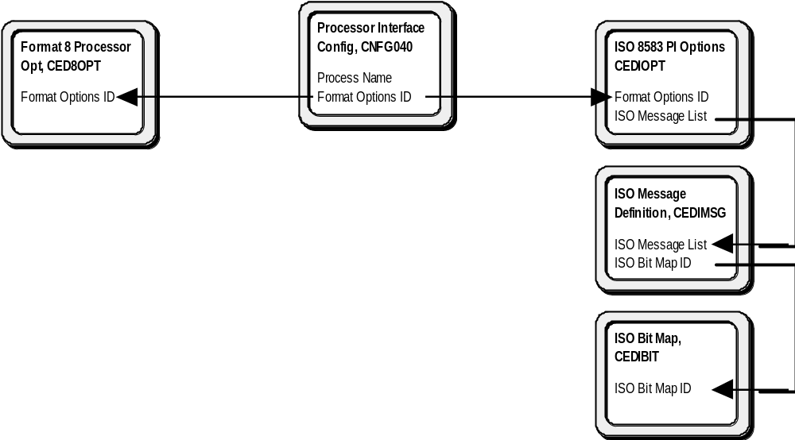
Based on the identifier entered in the Format Options ID field on the Processor Interface Configuration Record (CNFG040), a specific message structure is identified. The CED record used for Format 8 is described in this section.

Format 8 Processor Operations Record (CED8OPT)
The Format 8 Processor Operations Record controls the options for an eFunds Format 8 Processor Interface. It contains information regarding the operating environment for Format 8 processors.
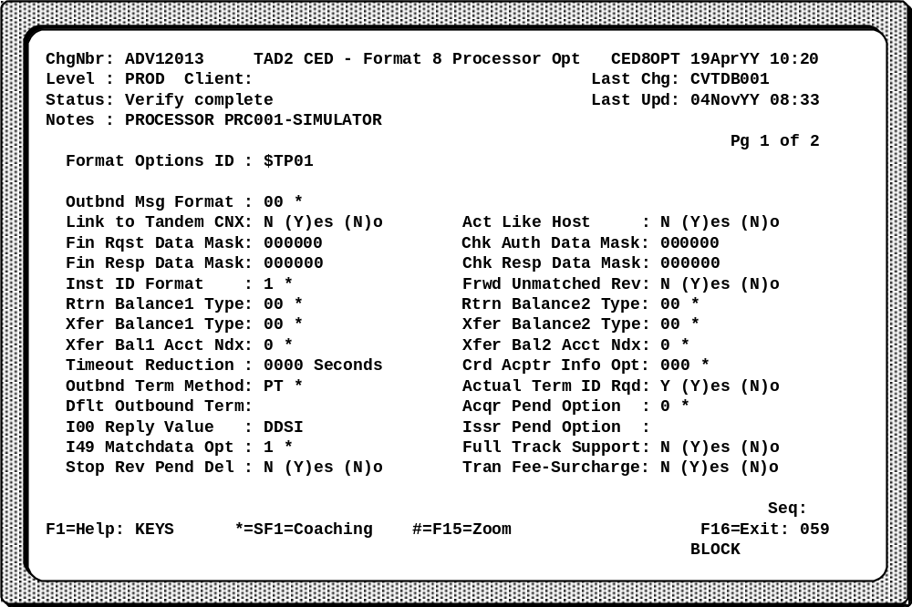
Outbnd Msg Format | Defines what release of Format 8 the Advantage system is using.
Link to Tandem® CNX | Identifies whether two Format 8 PIs have a peer-to-peer relationship.
Act Like Host | Controls whether this Format 8 PI acts as the slave processor or master processor. If two Format 8 processors have a peer-to-peer relationship, both Format 8 processors must have an N in this field. If two Format 8 processors have a master-slave relationship, the master processor must have an N in this field. The slave processor must have a Y in this field.
Acqr Pend Option | Controls pending on the acquiring side of the Format 8 PI.

Note: | The Link to Tandem® CNX and Act Like Host fields on the CED8OPT Record activates issuer pending in Format 8 PIs.
When implementing two Connex™ Advantage Tandem® links, both Advantage systems attempt to fill in the switch-assigned fields. This can cause major problems! To avoid problems, make sure the database fields are used appropriately, and have the corresponding processor values in both Advantage systems. Refer to the example below.
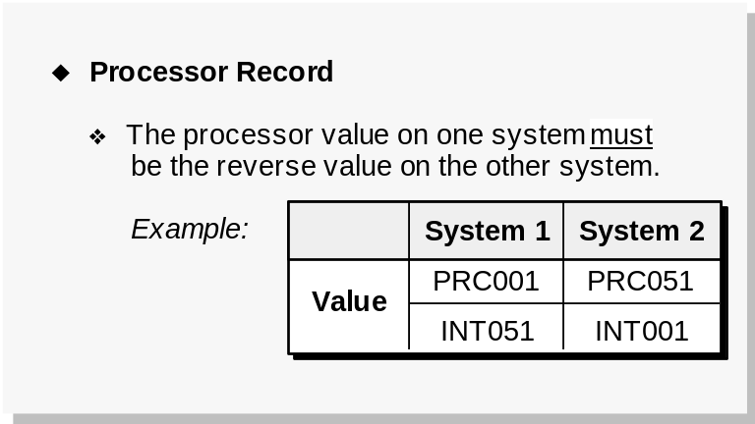

ISO 8583 PI Options Record (CEDIOPT)
The ISO 8583 PI Options Record controls the options for an eFunds ISO 8583 Processor Interface. It provides flexibility for configuring an eFunds ISO 8583 PI to another ISO 8583 PI. This record works with the ISO Message Definition Record (CEDIMSG) and the ISO Bit Map Record (CEDIBIT) to customize the data elements present in an ISO 8583 message.
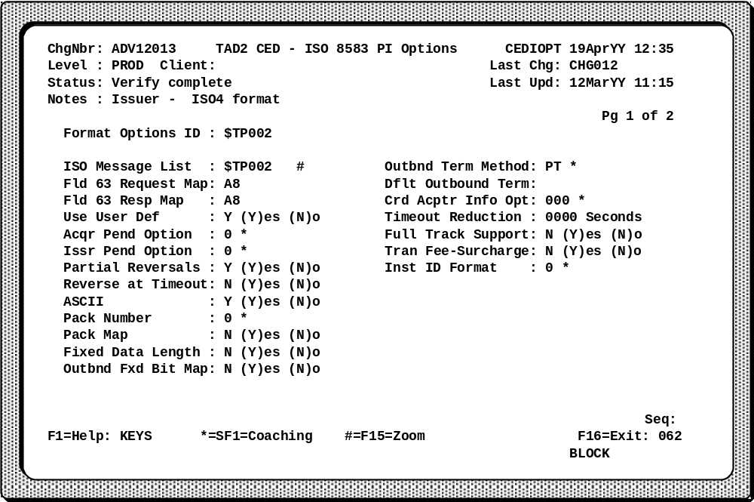
Format Options ID | Contains the linking identifier of the record that specifies the message structure options for an ISO 8583 PI.
ISO Message List | Identifies a list of ISO messages for use with the eFunds ISO 8583 PI.
Acqr Pend Option | Control pending on the acquiring side of the eFunds ISO 8583 Processor Interface. Pending is optional.
Issr Pend Option | Control pending on the issuing side of the eFunds ISO 8583 Processor Interface. Pending is optional and depends on the issuer’s requirements for data in a reversal and the Advantage system’s configuration.

ISO Message Definition Record (CEDIMSG)
The ISO Message Definition Record defines an ISO or ANSI message type that requires the presence of unique data elements. These requirements may be for an inbound message, an outbound message, or both. An eFunds ISO 8583 PI uses the information in this field to identify the format of inbound and outbound message. Each CEDIMSG Record has an associated bit map in an ISO Bit Map Record (CEDIBIT).
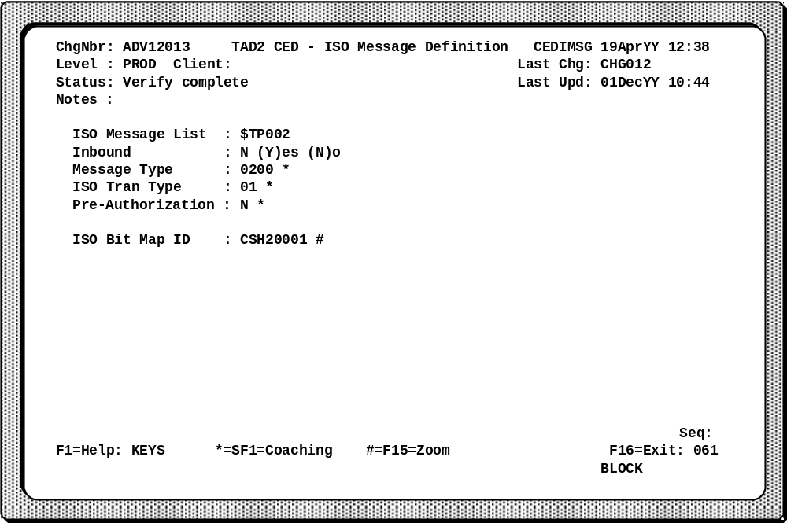
ISO Message List | Identifies a list of ISO messages for use with the eFunds ISO 8583 PI.
Inbound | Defines whether the data elements must be in an outbound message or an inbound message. To define an inbound message and outbound message for the same message type, enter two records.
Message Type | Identifies the four-digit numerical ISO message type.
ISO Tran Type | Identifies the first two digits of the ISO processing code. Including this field allows a bit map definition for a specific transaction code within a message type.
ISO Bit Map ID | Identifies a record in the ISO Bit Map File (CEDIBIT). Each specific message type has a different ISO Bit Map Record.

ISO Bit Map Record (CEDIBIT)
The ISO Bit Map Record specifies the data elements present in a message. Both ISO and ANSI messages use a 128-character bit map.
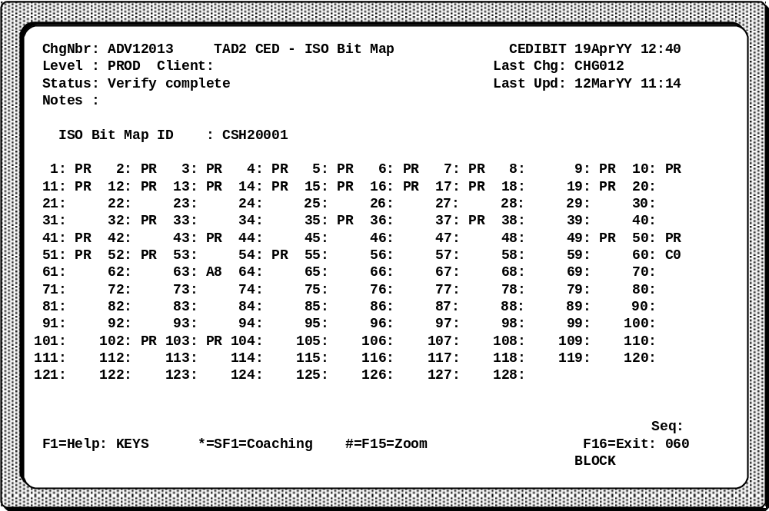
ISO Bit Map ID | Identifies a record in this file. Each specific message type may have a different CEDIBIT Record.
Bits | Determines if a conditional or optional data element defined in a specific ISO message is always present or never sent. Defined mandatory data elements are always present in the ISO or ANSI message. Therefore, the value of the Bit field does not affect whether a mandatory data element is present. Bits 60 and 63 are different; they contain a byte mask.

PI Swap File (SWPPI
Processor Interfaces now have refreshable swap files for the Connex™ Environmental Database (CED) parameters. Like other Advantage system processes, each PI has a swap file that is read into its extended memory at startup and/or refresh time. The location of this swap file is kept on the Processor Interface Configuration Record. All of the CED files that relate to the Processor Interface are present in the PI Swap File. These files are shown in the diagram below.
- Processor Interface Configuration (CNFG040)
- Intercept Terminal (CEDINTR)
- Processor (CEDPROC)
- Transaction Field Map Table Record (CEDMTBL)
- Transaction File Code Mapping Record (CEDCMAP)
- Data Mapping (CEDDMAP)
- Format 8 Processor Operations (CED8OPT)
- ISO 8583 PI Options Record (CEDIOPT)
- ISO Definition Record (CEDIMSG)
- ISO Bit Map Record (CEDIBIT)
- Session Services Message Options (CEDSOPT)
- Security Device Info Record (CEDSDEV)
- Valid Direct Route List (CEDVDIR)
If changes have been made to any of the processor-related files, an activation method must be used to get these changes into the Advantage system. In most instances, a PI process may be stopped to change some information on the existing processor records, and then the PI process restarted. Items requiring an outage (not refreshable) include adding a second processor record (acquirer/issuer), and changing the Queue File. Refer to the CED Procedures Manual for detailed instructions on adding processors.

Testing and Certification
Testing is a critical step in the implementation or maintenance of a processor. eFunds provides complete guides for testing the system. These guides include test scripts that help ensure with each new endpoint that all transaction types and routing takes place. Testing is done for many reasons:
- Ensures that transactions are routed, formatted, and reformatted correctly.
- Makes sure that the error conditions cause the desired responses.
- Checks that error recovery is successful.
- Tests all endpoint unique items for accuracy.
- Tests changes once the endpoint is in place to maintain proper processing.
Simulator | A testing tool that emulates a processor or an ATM and is used to create and send transactions to the Advantage system. It breaks down each message into its smallest meaningful components, and allows testers to alter messages and observe results. Simulators are used to test new software before it is installed in productive systems.
Stress test | File containing a large number of transactions that can be sent through the simulators at a rapid pace. This is useful to test how high volume situations affect the link.
Certification testing | Process of exhaustively testing an endpoint before allowing actual transactions to go through. Once all scenarios are thoroughly tested, the endpoint is considered certified, and the process of installing it into production may begin.

Simulators
The screen shown below is from the Format 8 simulator. It shows a transaction reply message. The Tandem®-Based Operations Manual describes the procedures for using simulators.
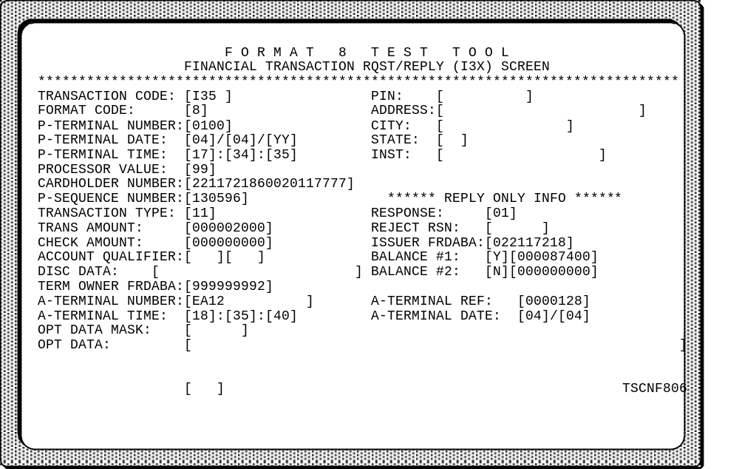

Review
- What are the major functions of the Processor Interface?
- Where are financial transactions timed in the Advantage system?
- What is the purpose of the Processor Output Queue, the Wait Queue, and the Queue File?
- What options are available for Delay processing?
- What are the key customer files involved with a Processor Interface?
A Processor Interface (PI) is an Advantage system process that handles the data exchange between an issuing or acquiring processor and the Advantage system. There are usually several PIs in a network; each is designed to meet specific requirements for the processor.
A PI uses a process called a Communications Handler (CH) to handle the circuits and protocol format required for telecommunications. This means that PIs with identical protocol requirements can share a CH. It is the Session Services (SS) component of the PI that provides the communication link to the CH.
The other component of the PI is called Application Services (AS). Application Services handles all of the additional major functions of a PI including message formatting, queue management and control, financial transaction timing, Delay processing, encrypted PIN handling, and command processing.
The Processor Interface monitors the financial transaction timing in the Advantage system. It uses milestones set by the Communications Handler in this determination. Also, the PI may perform data communication timing through the use of the Wait Queue and the Processor Output Queue. If a transaction reply arrives within the right time frame, the PI matches the request with the reply to ensure that transaction integrity is maintained. If the PI does not receive the correct response within the right time frame, it goes into a condition called Delay processing (Stand-In/Store-and-Forward). Transactions that the PI handles in Delay processing are written and stored on the Queue File.
The Queue File is a disk file that keeps a copy of each transaction approved during Stand-In and other must deliver messages, if the host is using alternative authorization. The host may decide not to allow the Advantage system to authorize any transactions in their absence (automatic decline option).
Hosts that use alternative authorization also need to decide which method of queue removal best fits their business needs. The most common of the exit Delay options is full interleaving. This places all transactions at a higher priority than the forced-post transactions and allows new transactions to reach the host immediately.
During Delay processing, the customer files used by the PI are the Negative File, the Usage File, and the Queue File. The Negative File contains a list of all cardholders that should be denied while in Stand-In. The Usage File tracks the daily dollar and card use of each cardholder while the PI is in Stand-In. The Queue File, also called the Store-and-Forward Queue, was described above.
Depending on specific circumstances, a PI may perform some or all of these functions.
Test your retention of the important concepts by completing the questions below.
1. List 5 major functions performed by the PI:
2. If you have a network with 5 different hosts and 15 ATMs, how many PIs (minimum) should you have in your Advantage system?
3. Name the two places where a financial transaction is timed (measured, not just timestamped) in the Advantage system:
4. Describe the function of the following items:
Processor Output Queue:
Wait Queue:
Queue File:

5. What are the two options for Stand In processing?
6. What is the purpose of the Usage and Negative Files?
7. What CED records are required for a PI?

Appendix A

Intercept PI: Routines for 110x/ 120x/ 140x/ 142x/ 144x if pending

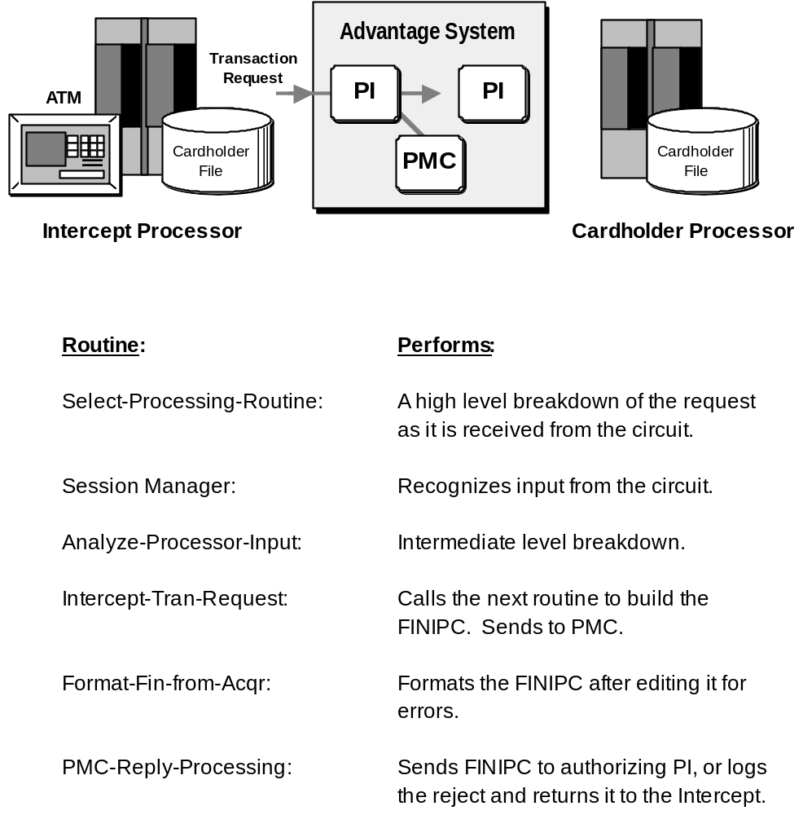

Cardholder PI: Routines for 110x or 120x

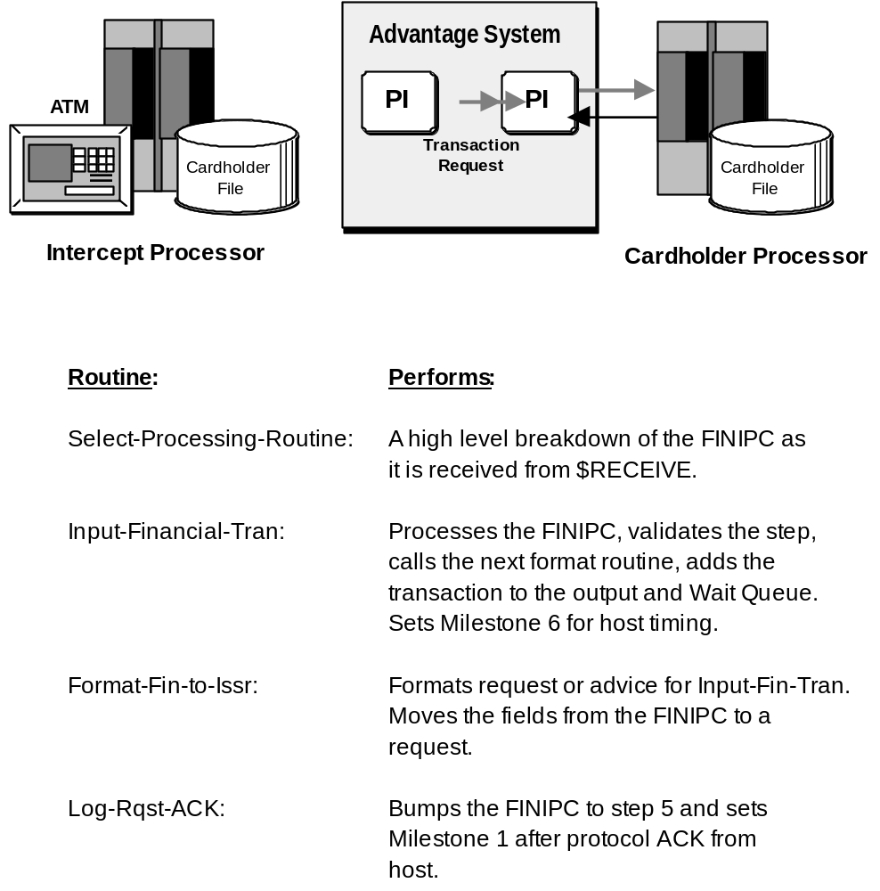

Cardholder PI: Routines for Fin Response

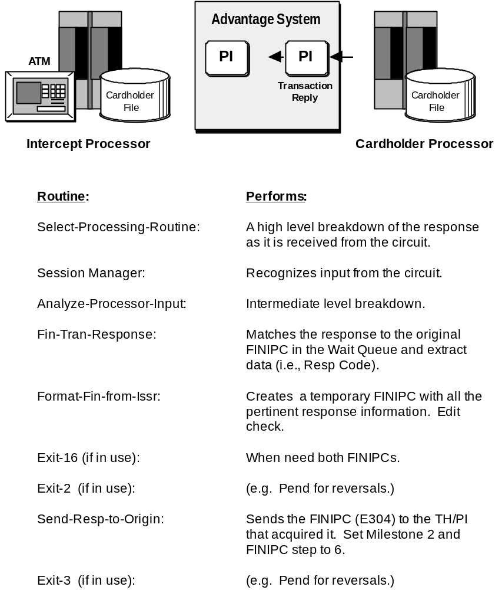

Intercept PI to Intercept Host: Routines for Fin Response

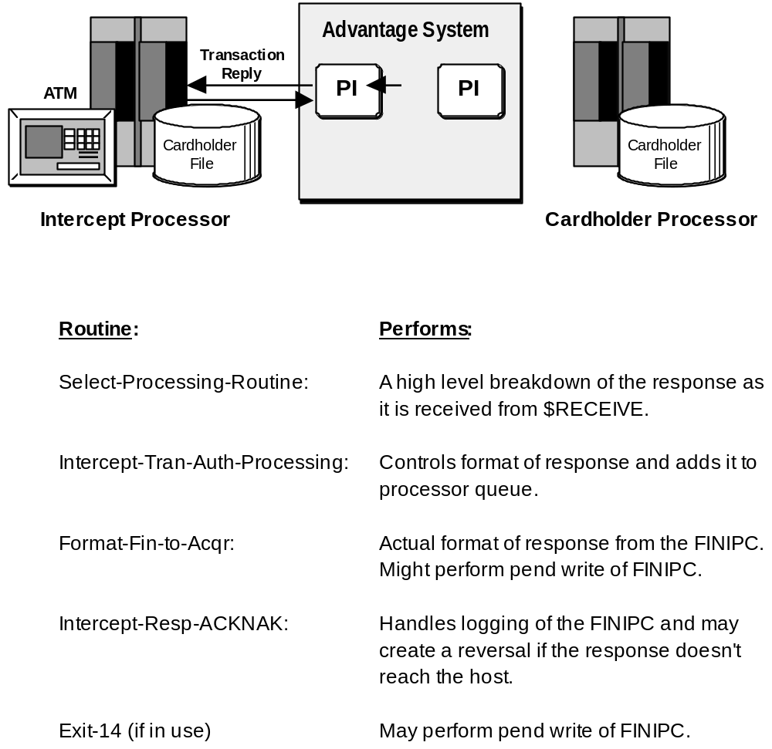

Reversal With PEND to Issuer PI: Routines for Reversals

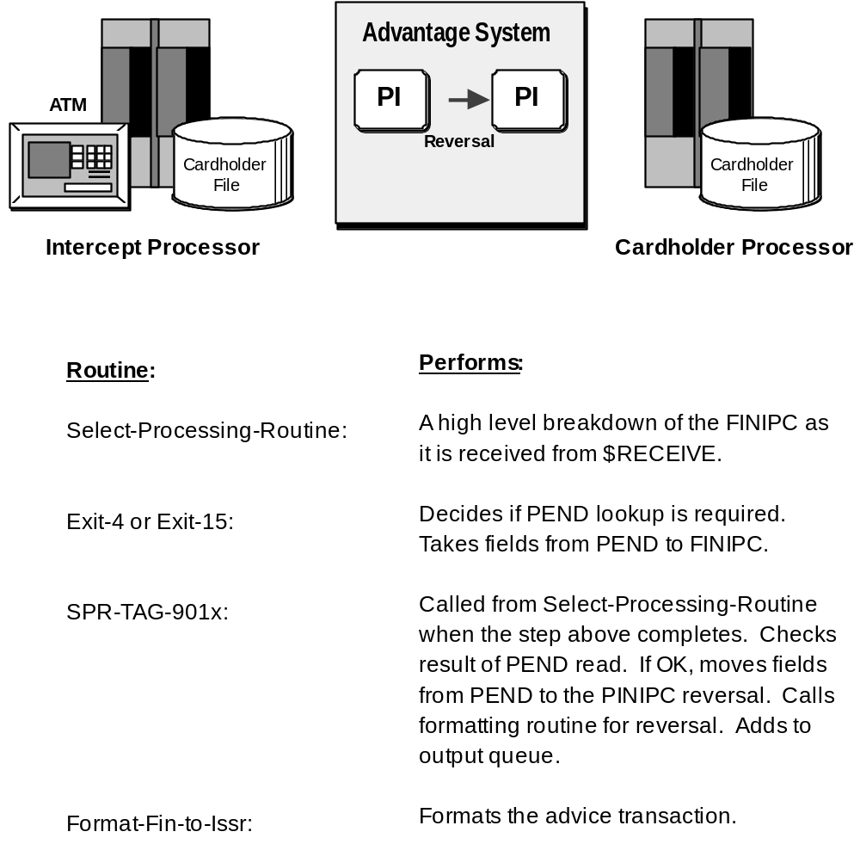

Reversal Without PEND to Processor PI: (Issuer Side) Routines for Reversals

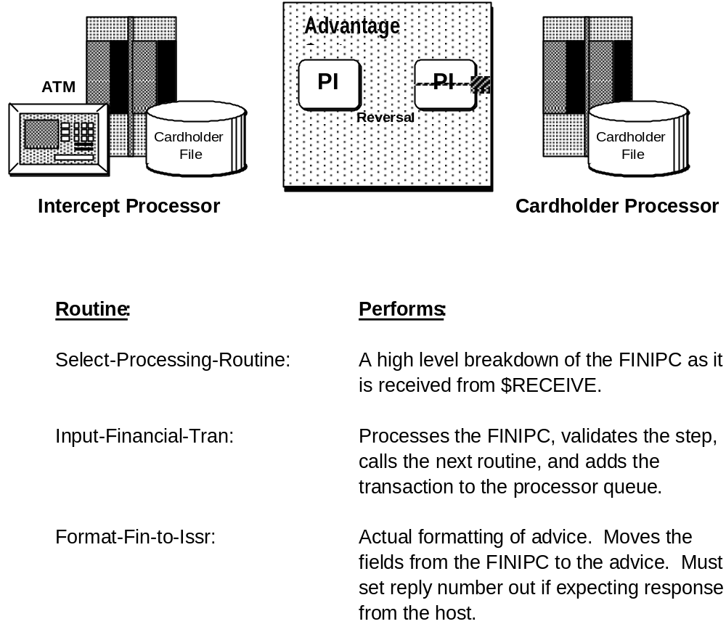

Reversal With PEND from Acquirer PI: (Acquirer Side) Routines for Reversals

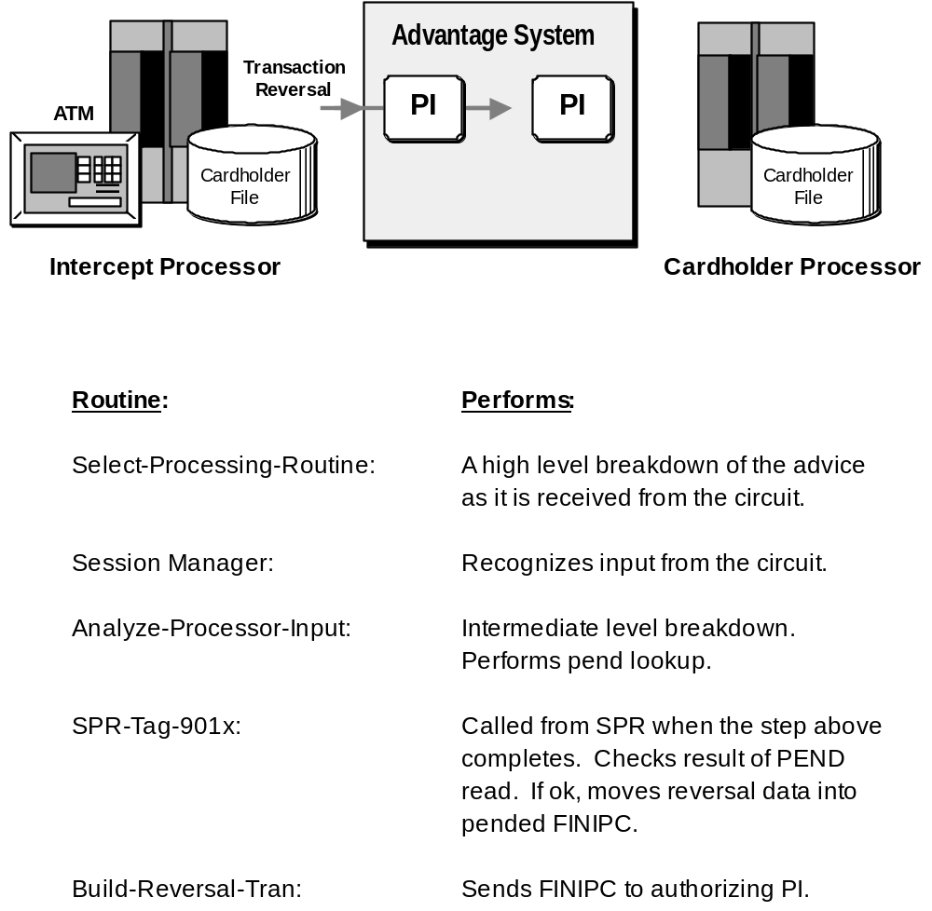

Appendix B

Session Message Options Table (CEDSOPT) Defaults

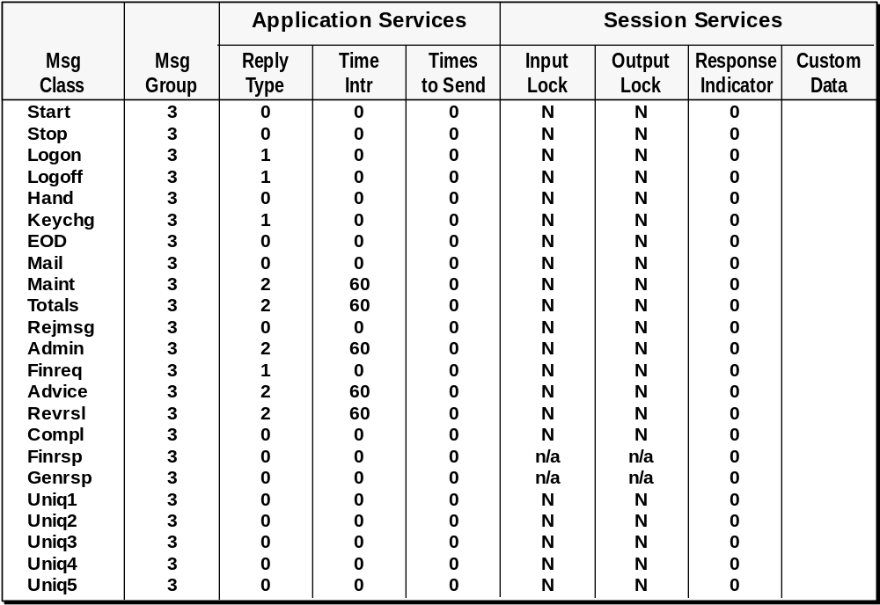
Leave lines alone from here to the end of the document.

